**INTERNSHIP PROJECT REPORT**



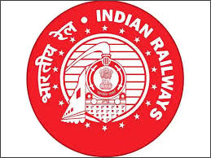

**EAST COAST RAILWAY CARRIAGE REPAIR WORKSHOP, MANCHESWAR, BHUBANESWAR**

**Submitted By:**

**Sanket Pradhan**

##### Bachelor of Technology in Electrical Engineering

##### Under the guidance of: Sri. Rakesh Malick JE/ Power Car

Acknowledgement

We are deeply grateful for the opportunity to work on this project titled **"Power Car Maintenance and Steps to Minimize Power Car Failure,"** which has significantly enhanced my practical understanding of electrical systems in the railway sector, particularly under East Coast Railways.

First and foremost, we would like to express my sincere thanks to **Sri Rakesh Malick**, Junior Engineer, for his expert guidance, valuable insights, and continuous encouragement throughout the project. His mentorship played a crucial role in shaping the direction and depth of this study.

We would also like to extend my gratitude to the entire team at **East Coast Railways**, especially those involved in the **Power Car Maintenance Unit**, for providing technical inputs, real-time data, and support that enriched the content and relevance of my work.

My sincere thanks to the **Department of Electrical Engineering** for their academic support and for providing the platform necessary for carrying out this project successfully.

We also appreciate the cooperation and support of my peers and friends, who contributed their ideas and encouragement during various stages of the project.

Lastly, we express heartfelt thanks to my family for their constant motivation, patience, and support throughout the completion of this project.

**CONTENTS**

|  |  |  |  |
| --- | --- | --- | --- |
| **Sl.no**  **.** | **CONTENT** | **PAGE NO.** | **REMARKS** |
| **1.** | **Introduction to Indian Railways & East Coast Railways** | **1-4** |  |
| **2.** | **Internship Report: Detailed study on Power cars in LHB coaches of Indian**  **Railways** | **5-27** |  |
| **3.** | **Power Car: Parts and Features** | 28-46 |  |
| **4.** | **Diesel Alternators: Parts and Safety Precautions** | 47-76 |  |
| **5.** | **Vibration Monitoring System, Fuel Leakage Detection, Remote Monitoring System (IoT based), Anti-pilferage System for Fuel, Exhaust Gas Temperature Monitoring** | 77-86 |  |
| **6.** | **Conclusion** | 87 |  |

INTRODUCTION

The **Indian Railways** is one of the largest and busiest rail networks in the world, operating under the **Ministry of Railways, Government of India**. It plays a crucial role in connecting the length and breadth of the country, facilitating not only passenger transportation but also the movement of goods and essential commodities across states. With its extensive network and significant contribution to economic and regional development, Indian Railways is often called the **lifeline of the nation**.

The **Indian Railways** is not just a mode of transport — it is an integral part of India's social, cultural, and economic fabric. Established in **1853**, with the first passenger train running between **Mumbai (Bori Bunder) and Thane**, Indian Railways has grown to become the **fourth-largest railway network in the world**, after the United States, China, and Russia.

Operated by the **Ministry of Railways**, it is a **state-owned national transporter** that manages one of the most complex and extensive rail systems globally. It spans over **68,000 kilometres** of track and services more than **7,000 stations**, carrying around **23 million passengers** and over **3 million tonnes of freight daily**.

To manage this vast network efficiently, the Indian Railways is divided into **17 zones**, each acting as a semi-autonomous administrative unit. These zones are further subdivided into divisions for operational convenience. Each zone is headed by a **General Manager (GM)** and operates under the control of the **Railway Board** in New Delhi.

Below is a list of the **17 railway zones** along with their respective

###### headquarters:

|  |  |  |  |  |
| --- | --- | --- | --- | --- |
| **Sl.no.** | **Zone Name** | | | **Headquarters** |
| 1 | Northern Railway (NR) | | | New Delhi |
| 2 | North  (NER) | Eastern | Railway | Gorakhpur |
| 3 | North Central Railway (NCR) | | | Prayagraj (Allahabad) |
| 4 | Eastern Railway (ER) | | | Kolkata |
| 5 | East Central Railway (ECR) | | | Hajipur |
| 6 | East Coast Railway (ECoR) | | | Bhubaneswar |
| 7 | Southern Railway (SR) | | | Chennai |
| 8 | South Central Railway (SCR) | | | Secunderabad |
| 9 | South Eastern Railway (SER) | | | Kolkata |
| 10 | South East Central Railway  (SECR) | | | Bilaspur |
| 11 | South (SWR) | Western | Railway | Hubballi |
| 12 | Western Railway (WR) | | | Mumbai (Churchgate) |
| 13 | West Central Railway (WCR) | | | Jabalpur |
| 14 | North  (NWR) | Western | Railway | Jaipur |
| 15 | North East Frontier Railway (NFR) | | | Maligaon (Guwahati) |
| 16 | Central Railway (CR) | | | Mumbai (CST) |
| 17 | Metro Railway (MR) | | | Kolkata |

**East Coast Railway (ECoR)**

The East Coast Railway (ECoR) is one of the 17 railway zones in India, functioning under the Ministry of Railways. Established on 1st April 2003, with its headquarters located at Bhubaneswar, Odisha, ECoR plays a significant role in connecting the eastern coast of India and facilitating the movement of both passengers and freight across several key states.

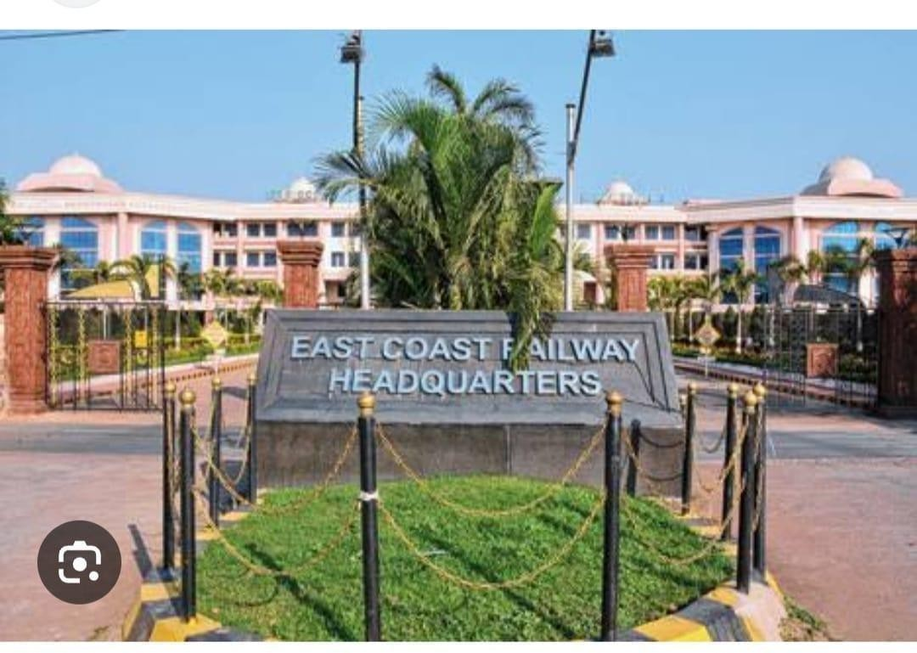

This zone primarily serves the states of Odisha, parts of Andhra Pradesh, and Chhattisgarh. It operates along some of the most economically vital and strategically important routes in the country, especially along the Howrah–Chennai main line, which is one of the busiest and most crucial railway corridors in India.

East Coast Railway is divided into three divisions:

1. Khurda Road Division – Bhubaneswar, Odisha
2. Waltair Division – Visakhapatnam, Andhra Pradesh
3. Sambalpur Division – Sambalpur, Odisha

ECoR is known for its high volume of freight traffic, particularly for transporting coal, iron ore, minerals, petroleum products, and other industrial commodities. Its proximity to several major ports such as Paradip, Visakhapatnam, and Gopalpur makes it a vital link in the country’s supply chain.

In addition to freight, the zone also operates an extensive passenger service network that connects important cultural, industrial, and tourist destinations in eastern India. With a strong focus on electrification, modernization, and digitalization, East Coast Railway is continuously improving its operational efficiency and service quality.

The zone has also been at the forefront of implementing advanced safety measures, infrastructure upgrades, and environmental initiatives. These include the use of energy-efficient locomotives, bio-toilets in coaches, and solar-powered stations.

Given its geographical and industrial significance, ECoR plays a critical role in India's rail infrastructure, making projects related to power car maintenance and reliability crucial for ensuring uninterrupted operations and energy efficiency across its network.

This project focuses particularly on **Power Car Maintenance** under East Coast Railway, highlighting the current practices, common causes of failures, and proposed methods to reduce breakdowns and improve operational reliability.

### Internship Report: Detailed Study on Power Cars in LHB Coaches of Indian Railways

**Introduction**

During my internship with Indian Railways, I undertook a detailed study of the power cars used in LHB (Linke Hofmann Busch) coaches. These coaches, imported and adapted from German technology, represent a significant advancement in passenger rail transport in India. LHB coaches are designed to be safer, faster, and more comfortable compared to the older ICF coaches. Since most LHB coaches are air- conditioned, a consistent and reliable source of electrical power is essential. This power is provided by specially designed coaches known as power cars. These cars are equipped with generator systems and auxiliary systems to ensure uninterrupted power supply to all coaches in the rake.

* LHB coaches rely on a centralized power system.
* Power cars are specially designed to provide electrical energy.
* They contain diesel generators and distribution systems.
* They ensure lights, fans, air-conditioning, and other utilities remain functional.
* Power cars also ensure uninterrupted food service operations in pantry cars.
* Built for reliability, they can handle fluctuations and peak loads.
* They operate safely under extreme weather and load conditions.
* The design includes safety, maintenance, and acoustic considerations.
* Power cars represent the intersection of mechanical and electrical engineering.
* They form the backbone of the EOG system used in non-HOG trains.

Power Car in LHB Coaches – A Dedicated Engineering Unit

A power car in an LHB rake is a self-contained, high-capacity electrical powerhouse. It not only supports the coach systems but also plays a crucial role in the safety, communication, and control aspects of the train. Power cars are robustly engineered to endure vibrations, shocks, and thermal stresses experienced during long-distance rail travel. From energy production to its regulation, every component inside a power car is designed with precision and redundancy to avoid failure.

* Acts as the ‘engine room’ for electrical needs.
* Built with fire-retardant materials for safety.
* Equipped with safety doors, alarms, and fire detection.
* High-capacity ventilation fans maintain operational temperatures.
* Acoustic insulation ensures noise levels are under control.
* Houses backup power systems in many configurations.
* Completes with RDSO and ICF safety norms.
* Designed with ergonomics for easy access and maintenance.

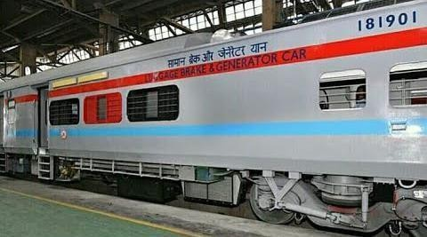

Structural Layout and General Arrangement of Power Cars

A typical LHB power car has a length of approximately 23.54 meters, a width of 3.24 meters, and a height of around 4.05 meters. It weighs about 55 tons when empty.

Internally, the power car is divided into multiple compartments, each with a specific function. These include the generator room, the control and monitoring panel room, the fuel tank compartment, a tool and storage area, and in some cases, a small resting space for staff. The layout is carefully designed to ensure optimal utilization of space, efficient heat dissipation, and ease of maintenance. The generator room is centrally located and soundproofed, while ventilation systems are provided throughout to maintain safe working temperatures. Emergency exits and fire-resistant doors are also incorporated to ensure operational safety under all conditions.

Main Compartments:

* Generator Room: Soundproofed and heat ventilated.
* Control Room: Houses, panels and indicators.
* Fuel Tank Area: Securely mounted underframe tank.
* Tool and Storage Area: For spares, fuses, and filters.
* Staff Cabin: Resting facility with basic amenities.

Generator Systems and Electrical Supply Mechanism

At the heart of the power car is the diesel-powered generator set. These heavy-duty engines are typically manufactured by trusted companies such as Cummins or Kirloskar. Each set can produce between 500 kVA and 750 kVA at an operating speed of 1500 RPM, which is standard for railway applications. The generator functions by converting the mechanical energy from the diesel engine into electrical energy through an alternator. The generated electricity is distributed via a

415V, 3-phase, 50Hz supply to all coaches. Key supporting systems include automatic voltage regulators (AVRs), protective relays, and control logic to prevent faults.

Radiator-based cooling systems, either air-cooled or water-cooled—ensure that the engines operate within safe temperature ranges. Continuous performance is ensured by integrating vibration isolation mounts, engine silencers, and proper exhaust routing systems.

Features of the Generator System:

* Engine + Alternator setup (DG Set).
* Output: 415V, 3-phase, 50Hz.
* Capacity: Up to 750 kVA.
* Cooling: Radiator-based with air or water cooling.
* Control: AVR and relay-based protection.

###### MAJOR COMPONENTS OF A POWER CAR:-

The main parts used in a power car according to the catalogue along with its indentation are given below: -

1. PUMP, LUBRICATING OIL – LP4706
   * This is a gear-type oil pump used to circulate lubricating oil throughout the diesel engine of the power car.
   * It ensures that moving engine parts like crankshaft, camshaft, and bearings are properly lubricated.
   * The pump draws oil from the oil sump and sends it under pressure to critical components.
   * It helps reduce friction and wear, thereby extending engine life.
   * Maintains the correct oil pressure for efficient engine operation.
   * The pump is usually driven mechanically by the engine itself.
   * If this pump fails, the engine can seize due to lack of lubrication.
   * It works continuously while the engine is running at varying speeds.

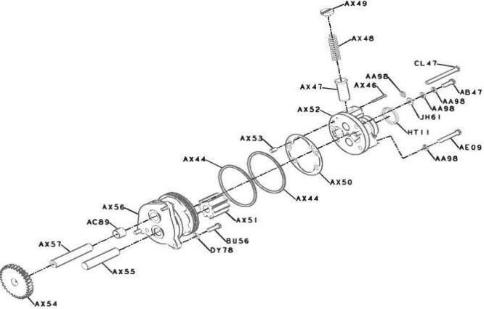

1. ACCESSORIES, FUEL SYSTEM – FS4076
   * These include filters, pipes, valves, clamps, and pressure regulators in the fuel system.
   * Ensure smooth delivery of diesel from the fuel tank to the injectors.
   * Maintain the required pressure and purity of the fuel.
   * Protect engine parts from contaminants or water in the fuel.
   * These accessories reduce the risk of clogging and misfiring.
   * They help maintain efficient combustion and reduce fuel consumption.
   * Components are designed to be resistant to corrosion from diesel.
   * Include return lines for unburnt fuel back to the tank.
   * Critical for maintaining consistent engine performance during long hauls.
2. ACCESSORIES, WIRING – EA4101
   * Refers to electrical accessories like connectors, junction boxes, harnesses, terminals, etc.
   * These are used to distribute electrical power within the diesel generator system.
   * Ensure secure and weatherproof connections between sensors, relays, and controllers.
   * Wires must resist vibration, heat, oil, and diesel exposure.
   * Essential for connecting control units to devices like fuel pumps, alternators, and sensors.
   * Bad wiring can cause short circuits, overheating, or system failures.
   * Color-coded and tagged for easy troubleshooting and maintenance.
   * Play a key role in automated engine monitoring and safety systems.
   * Designed to meet railway standards for flame retardance and insulation.
3. ADAPTER, OIL PAN – OP4891
   * This component acts as a mounting interface between the engine block and the oil pan.
   * Provides leak-proof sealing while allowing proper alignment of oil pan components.
   * Often includes ports or holes for sensors, drainage, or oil suction pipes.
   * Made of high strength cast aluminum or steel to withstand engine vibrations.
   * Ensures proper fitment and prevents oil leakage from the pan area.
   * Facilitates easy removal and reinstallation during maintenance.
   * Help in maintaining the correct oil flow path to the pump.
   * Designed to absorb thermal expansion between engine block and pan.
   * It can come with gasket grooves to enhance sealing efficiency.
   * Plays a subtle but essential role in the lubrication system’s durability.

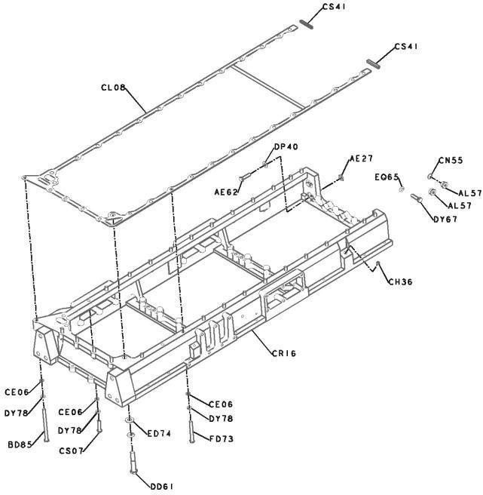

1. APPROVAL, AGENCY – AP4169
   * Refers to certification/inspection approvals given by regulatory authorities or OEMs.
   * Ensures that engine parts and power car systems meet Indian Railway standards.
   * This code may relate to documentation of quality checks or vendor qualification.
   * Necessary for traceability and legal compliance in procurement and maintenance.
   * Usually issued by agencies like RDSO (Research Designs & Standards Organisation).
   * Ensures parts used in the power car are safe, reliable, and standardized.
   * Covers aspects like fire safety, performance, emissions, and material quality.
   * Helps in warranty claims and identifying genuine vs. counterfeit parts.
2. ARRANGEMENT, CRC BREATHER – BR4103
   * CRC breather (Crankcase breather) helps release internal engine pressure safely.
   * Prevents oil leaks by balancing pressure in the crankcase with ambient pressure.
   * Filters out oil vapors and directs them back to the intake or atmosphere.
   * Avoids formation of sludge or excessive pressure inside the engine block.
   * Reduces the emission of unburned hydrocarbons and oil mist.
   * Prevents dust or dirt from entering the crankcase through vent ports.
   * Keeps engine seals and gaskets intact by pressure regulation.
   * Plays a role in maintaining environmental compliance.

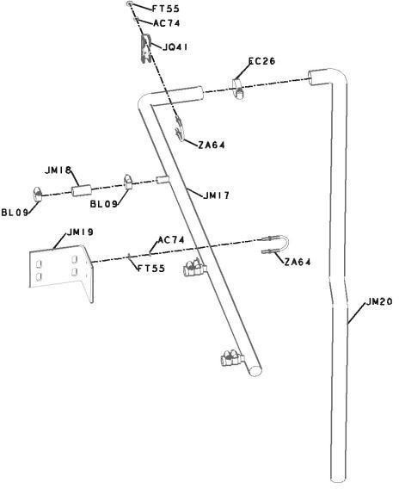

1. ARRANGEMENT, LIFTING – LA4019
   * Refers to lifting lugs or eyes fitted on the engine for safe handling.
   * Used during installation, removal, or transport of the engine or generator.
   * Designed to carry the full weight of the engine safely using cranes or hoists.
   * Made from forged steel with certified load-bearing capacity.
   * Strategically placed for balanced lifting without damaging components.
   * Critical during maintenance or engine replacement in sheds.
2. ARRANGEMENT, OIL FILL – OB4186
   * This is the filler arrangement used to add lubricating oil into the engine.
   * Includes a filler neck, cap, funnel, and sometimes a strainer.
   * Designed for easy access during routine oil top-up or refill.
   * Oil cap usually includes a seal or gasket to prevent oil vapor escape.
   * Located at a convenient spot on the valve cover or side block.
   * Some versions include a dipstick hole for checking oil levels.
   * Must be tight-fitting to avoid dust or moisture entering the system.
   * Critical for engine oil management and preventive maintenance.
   * Without this, the oil system cannot be properly serviced or refilled.

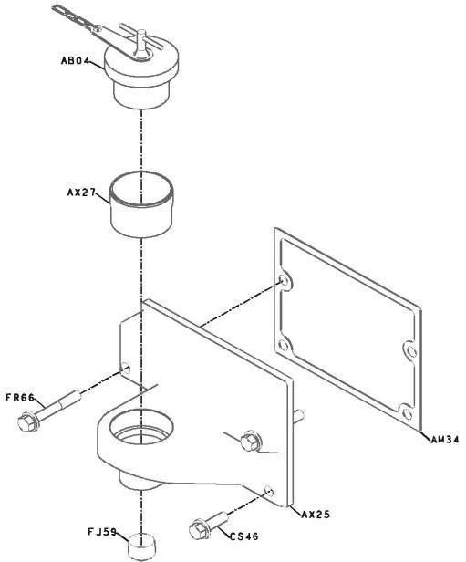

1. ARRANGEMENT, TURBOCHARGER – TB4153
   * A complete mounting and plumbing arrangement for turbocharger setup.
   * Include mounting brackets, oil supply and return pipes, gaskets, etc.
   * Helps in routing exhaust gases to the turbo turbine efficiently.
   * Also manages compressed air flow to the intake manifold.
   * Ensure that the turbocharger operates at optimum pressure and temperature.
   * Uses heat-resistant materials to withstand exhaust gas temperature.
   * Includes vibration isolators or supports to absorb engine movement.
2. BLOCK, CYLINDER – BB4753
   * The cylinder block is the heart of the engine where combustion happens.
   * Made of cast iron or alloy steel, it houses cylinders, pistons, and crankshaft.
   * Supports the installation of valve head, oil galleries, and coolant passages.
   * Contains the main journals where crankshaft rotates.
   * Includes mounting points for oil pan, engine mounts, and auxiliary part.
   * Coolant jackets inside regulate temperature during operation.
   * Any crack or warping can lead to oil mixing with coolant or loss of compression.
   * This is the main structure that holds and supports the entire engine.
3. BRACKET, SHIPPING – SK4017
   * This is a temporary support bracket used during the transportation or shipping of the engine or generator.
   * Ensures the engine remains secure and stable in transit, preventing damage.
   * Usually bolted or clamped to the engine frame or base.
   * Made of sturdy steel or alloy to resist vibration and impact.
   * Helps in position locking of rotating parts like flywheels during shipping.
   * Prevents shifting or swaying of engine parts in case of jolts during train or truck movement.
   * Includes slots or holes for straps or clamps to hold in place.
   * Essential for safety and mechanical integrity during long-distance transport.
4. CAMSHAFT – PP44575_CAMSHAFT
   * A long shaft inside the engine that controls the opening and closing of valves.
   * Rotates in sync with the crankshaft, usually at half its speed.
   * Has lobes (cams) which press against valve lifters to control air–fuel intake and exhaust.
   * Driven via gear or chain from the crankshaft.
   * Poor camshaft timing causes misfiring, knocking, or loss of power.
   * Made of high-strength alloy steel to resist wear and friction.
   * Located in the cylinder block or head, depending on engine design.
   * A worn camshaft can cause irregular engine operation and valve damage.

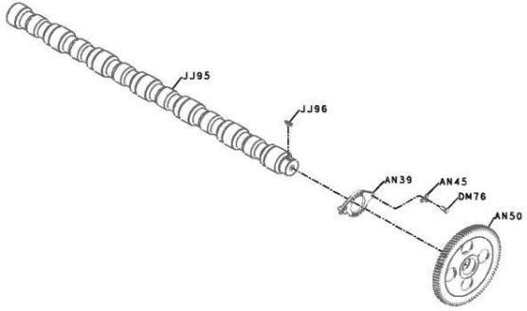

1. CLEANER, AIR – AC4143
   * This is the air filter system used to clean incoming air before it enters the turbocharger or intake manifold.
   * Removes dust, dirt, and particles from the atmosphere to protect engine internals.
   * Usually a multi-stage filter with paper or synthetic filter elements.
   * Clean air improves combustion efficiency and engine life.
   * Prevents scoring of cylinder walls or piston damage due to dust ingestion.
   * Requires regular cleaning or replacement to maintain optimal air flow.
   * Fitted in a sealed canister with an inlet and outlet path.
2. CONNECTION, AIR TRANSFER – IT4036
   * A piping or ducting setup that transfers compressed air from turbocharger to intake manifold.
   * Made of heat-resistant aluminum or rubber hoses to handle high-pressure air.
   * Ensures the engine receives boosted, oxygen-rich air for better combustion.
   * Proper sealing is essential to avoid air leakage, which can reduce efficiency.
   * Designed to absorb vibration and engine movement without cracking.
   * Includes clamps, O-rings, or bellows for flexibility and durability.
   * Must maintain air pressure and flow consistency at all engine speeds.
3. CONNECTION, EXHAUST – XS4147
   * This is the duct or pipe that connects the engine exhaust manifold to the turbocharger or muffler.
   * Carries hot exhaust gases at high speed and pressure.
   * Made of high-temperature steel or flexible metal hose.
   * Must be heat-resistant and corrosion-proof, as it handles acidic gases.
   * Help drive the turbocharger turbine using exhaust gas energy.
   * Includes expansion joints to absorb heat expansion and vibrations.
   * May have insulation wrap to contain heat and protect nearby components.
   * Essential for emissions control and power recovery through turbocharging.

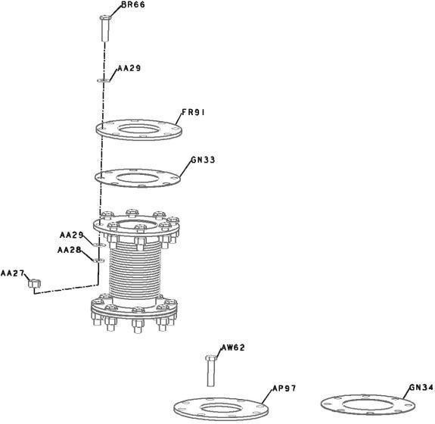

1. CONNECTION, EXHAUST OUTLET – XS4135
   * This pipe carries exhaust gases from turbocharger to the muffler or outlet.
   * Acts as the final leg of the exhaust flow in the power car engine.
   * Must ensure free and safe flow of gases to avoid back-pressure.
   * Usually made from steel alloy, capable of handling high temperatures.
   * Designed to route exhaust away from the engine room and personnel.
   * Any leaks here can lead to toxic gas exposure or fire hazard.
   * May include flexible couplings for thermal and vibration compensation.
   * Ensures proper exhaust noise suppression when connected to the muffler.
   * Requires corrosion resistance due to exposure to moisture and soot.
   * Completes the engine’s exhaust gas management system.
2. CONNECTION, WATER INLET – WI4025
   * This is the inlet port for coolant entering the engine block.
   * Receives coolant from radiator or coolant pump.
   * Designed to direct coolant flow into cooling jackets of the cylinder block.
   * Made of corrosion-resistant metal or plastic, sealed with gaskets.
   * Ensures proper temperature control of combustion chamber and valves.
   * Help prevent overheating, thermal distortion, and engine failure.
   * Includes temperature sensors for monitoring cool temperature inlet.
   * A damaged or blocked inlet can result in hot spots or engine seizure.
3. CONNECTION, WATER OUTLET – WO4062
   * This is the outlet through which heated coolant exits the engine to the radiator.
   * Located at the highest point of the cylinder head to ensure efficient heat removal.
   * Channels hot coolant to cooling system (usually via thermostat housing).
   * Ensures that coolant maintains optimal operating temperature for the engine.
   * Made from cast aluminum or alloy and fitted with gaskets or O-rings.
   * Maintains a sealed coolant loop for consistent flow and pressure.
   * Outlet also serves as a mount for temperature sensors or thermostat.
   * Must be leak-free to avoid loss of coolant and engine overheating.
4. COOLANT, ENGINE – CT4009
   * This is the liquid (usually water and antifreeze mix) used to cool the engine.
   * Circulating through the engine block, absorbing heat from combustion.
   * Then passes through the radiator, where heat is expelled to the air.
   * Contains anti-corrosion and anti-freeze additives to protect components.
   * Prevents overheating, boiling, and engine seizure during operation.
   * Maintains thermal stability even in harsh Indian climates.
   * It must be periodically replaced to avoid scaling and rusting inside the engine.
   * Works in combination with water pump, radiator, thermostat, and hoses.
5. COOLER, ENGINE OIL – LC4733
   * A heat exchanger is used to reduce the temperature of engine lubricating oil.
   * Maintains oil viscosity within optimal range for effective lubrication.
   * Uses coolant or air to absorb heat from hot engine oil.
   * Prevents oil breakdown and engine component wear due to high temperatures.
   * Located between oil pump and engine lubrication lines.
   * Helps maintain oil temperature under heavy engine loads.
   * Made from aluminum or stainless steel with internal flow passages.
   * Ensure smooth engine operation by cooling the lubricant constantly.
6. COVER, CAMFOLLOWER – CM4726
   * This cover encloses the cam follower mechanism located over the camshaft.
   * It prevents dust, dirt, and moisture from entering the cam follower area.
   * Made of die-cast aluminum or sheet metal, designed for easy removal.
   * Ensures safe lubrication of followers without external contamination.
   * Prevents oil spillage by acting as a sealed enclosure.
   * Requires gaskets or O-rings to seal the joint with the engine body.
   * Important for maintaining the mechanical timing and operation of valves.

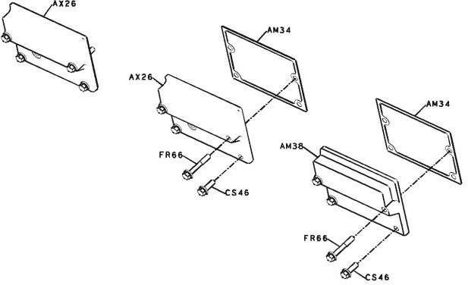

1. COVER, FRONTGEAR – GG4768
   * Enclosed the front gear assembly which may drive camshaft, fuel pump, or other accessories.
   * Shields the gears from dust, water, and external damage.
   * Made of machined cast iron or steel for mechanical strength.
   * Houses a lubrication system to ensure proper gear functioning.
   * Sealed using gaskets or liquid sealants to prevent oil leakage.
   * Also supports the front oil seal around the crankshaft.
   * Covers gear train responsible for engine timing and accessory drive.
   * Prevents injury from rotating gears and reduces gear noise.
   * A heat exchanger is used to reduce the temperature of engine lubricating oil.
   * Maintains oil viscosity within optimal range for effective lubrication.
   * Uses coolant or air to absorb heat from hot engine oil.
   * Prevents oil breakdown and engine component wear due to high temperatures.
   * Located between oil pump and engine lubrication lines.
   * Helps maintain oil temperature under heavy engine loads.
   * Made from aluminum or stainless steel with internal flow passages.
   * Ensure smooth engine operation by cooling the lubricant constantly.
2. COVER, HANDHOLE – OB40134
   * A small removable inspection cover located on the engine block.
   * Used for maintenance access to internals like connecting rods or oil passages.
   * Allows checking of engine internals without full disassembly.
   * Sealed tightly to avoid oil leakage or dust entry.
   * Made of metal or composite materials, with bolt or clamp fixtures.
   * Enables mechanics to inspect wear and tear inside the engine.
   * Vital in large engines where internal accessibility is otherwise limited.
3. COVER, VALVE – VC4716
   * Also known as rocker cover, this sits atop the cylinder head.
   * Enclosed valve train components such as rocker arms and camshafts.
   * Prevents oil from spilling and blocks dust or dirt ingress.
   * Usually made of aluminum or pressed steel, shaped to engine contour.
   * Includes oil fill port and sometimes a breather or PCV valve.
   * Ensures engine cleanliness, noise reduction, and proper oil circulation.
   * It is important for protecting the valve train and oil flow system.
4. DEVICE, SIGNALGENERATING – EO4010
   * Likely refers to a sensor-based device that produces electrical signals.
   * Converts mechanical movements into electrical pulses or voltage signals.
   * Can be used for RPM sensing, position tracking, or timing.
   * Works with the ECU (Electronic Control Unit) for engine management.
   * Often a Hall effect sensor or magnetic pickup device.
   * Mounted near rotating components like crankshaft or camshaft.
   * Failure may result in misfiring or engine control issues.
   * Essential for modern electronically governed diesel engines.

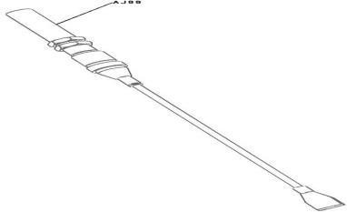

1. DRIVE, BARRING – CB4705
   * A manual or motorized mechanism used to rotate the engine slowly.
   * Allows technicians to position the crankshaft or piston for maintenance.
   * Commonly used during timing adjustments, valve setting, or inspection.
   * Usually includes a barring motor or hand barring device with a gear system.
   * Mounted near flywheel housing or crankshaft pulley.
   * May include lock pins or ratchets for safety.
   * Aids in non-invasive internal alignment before startup.
   * Very useful for checking valve timing, piston position, or top dead center.
   * Critical for safe, controlled engine rotation during service.

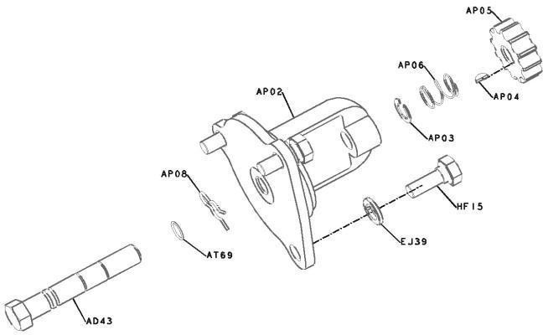

1. DRIVE, FUEL PUMP – DP4713
   * Transfers rotational power from the engine to the fuel pump assembly.
   * Ensures precise timing and delivery of fuel to the injectors.
   * It can be gear-driven, chain-driven, or via a coupling mechanism.
   * Syncs with engine rotation to match injection timing with piston movement.
   * Essential for maintaining correct engine performance and combustion.
   * Damage or misalignment can cause fuel starvation or engine knocking.
   * Often housed in a case to avoid external damage or misfire.
   * A key link in the fuel injection and power delivery system.
2. FILTER, FUEL – FF4172
   * Removes dust, rust, and moisture from the diesel fuel before it enters the injectors.
   * Protects fuel pumps and injectors from damage due to impurities.
   * Usually a cartridge or spin-on type filter, replaceable during servicing.
   * Fit in the fuel line between tank and engine.
   * It consists of fine paper or synthetic media to trap micro-particles.
   * Prevents clogging, misfiring, and injector wear due to dirty fuel.
   * Transparent housing helps visually inspect clogging or sediment.
   * One of the most critical parts in fuel system health and performance.
3. FILTER, LUBRICATING OIL – LF4098
   * Cleans the engine oil by removing carbon, metal particles, and sludge.
   * Located in the lubrication circuit just after the oil pump.
   * Keeps oil free from contaminants, ensuring smooth engine operation.
   * Typically uses a replaceable filter element made of pleated paper or mesh.
   * Crucial for engine life, wear reduction, and smooth operation.
   * A clogged oil filter can cause oil starvation and engine seizure.
   * Vital for protecting bearings, pistons, and camshaft from abrasive wear.
4. FILTER, OILBYPASS – OF4740
   * A secondary filter that handles part of the oil flow under specific conditions.
   * Filters fine particles without affecting main oil pressure or flow.
   * Used to extend the life of primary oil filters and oil itself.
   * Allows controlled diversion of oil for ultra-fine filtration.
   * Designed with a very fine filtration mesh or media.
   * Aids in keeping oil cleaner for longer during heavy-duty operations.
   * It is important for engine health in high-load, continuous-run conditions like power cars.

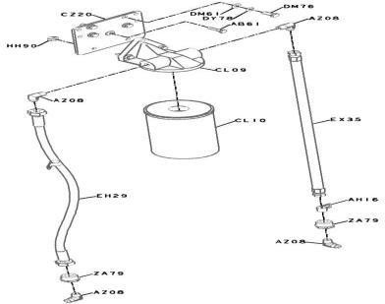

1. FITTING, FUEL PUMP – FF4748
   * This is a mechanical or threaded connector used to join the fuel pump to the engine or fuel lines.
   * Ensures leak-proof sealing between the pump and fuel supply system.
   * Can include banjo bolts, compression fittings, or flanges.
   * Made of corrosion-resistant steel or brass to withstand diesel and pressure.
   * Allows quick removal and installation of the fuel pump during maintenance.
   * May have O-rings or sealing washers to prevent leakage.
   * Ensures the fuel pump operates safely without fuel starvation.
   * A small but essential component in the fuel injection architecture.
2. FLYWHEEL – FW4160
   * A heavy rotating disc mounted on the engine's crankshaft.
   * Stores rotational energy and maintains engine speed between power strokes.
   * Smooths out power pulses and ensures balanced operation.
   * Made of cast iron or steel, with a ring gear for the starter motor.
   * Essential for starting the engine and driving the clutch in transmission systems.
   * Help in reducing vibration and torsional irregularities in engine rotation.
   * Often have timing marks used for setting injections or valve timing.
   * Plays a vital role in engine stability and torque transmission.
3. GAUGE, OIL LEVEL – LG4849
   * A dipstick-type or electronic sensor device is used to measure engine oil level.
   * Ensure proper oil quantity is maintained for engine lubrication.
   * Manual types have MIN–MAX markings for visual inspection.
   * Electronic types send signals to the dashboard or monitoring system.
   * Helps prevent engine damage due to oil shortage or excess.
   * Should be checked regularly as part of routine maintenance practices.
   * Crucial for ensuring engine safety and operational reliability.
4. HEAD, CYLINDER – PP44575_HEAD_CYLINDER
   * Forms the top portion of the engine cylinder and seals the combustion chamber.
   * Houses have important components like valves, injectors, camshaft, and ports.
   * Made from cast iron or aluminum alloy for heat resistance.
   * Withstand high pressure and temperature during combustion.
   * Has passages for coolant and lubricating oil.
   * Supports the operation of valve timing mechanisms and injector nozzles.
   * Its design directly affects engine efficiency, power, and emissions.
   * A metal casing that encloses and supports the flywheel and starter ring gear.
   * Mounted at the rear of the engine, connects to the transmission or generator.
   * Protects the flywheel from dust, debris, and mechanical damage.
   * Often includes starter motor mounting points.
   * Helps maintain proper alignment between engine and driven units.
   * Acts as a support frame during lifting or handling of the engine assembly.
   * Usually made of cast iron or steel for strength and durability.
   * Vital for safe housing and alignment of rotating components.
5. HOUSING, THERMOSTAT – TH4783
   * Encloses the thermostat valve and connects coolant passages.
   * Controls flow of coolant between the engine and radiator based on temperature.
   * Opens or closes the thermostat to regulate engine temperature.
   * Usually made of aluminum, plastic, or cast iron.
   * Located at the engine block or cylinder head outlet.
   * Prevents engine from overheating or operating below optimum temperature.
   * It has mounting flanges and rubber seals/gaskets to prevent coolant leakage.
   * Important for thermal management and engine efficiency.

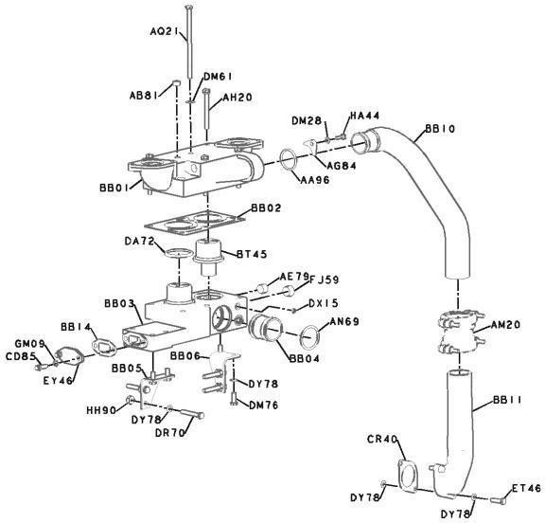

1. HUB, TIMING – AD4709
   * This hub is connected to the crankshaft or camshaft to set engine timing.
   * Helps drive timing gears or timing chains.
   * Ensures precise coordination between piston movement and valve operation.
   * Any misalignment can cause poor performance or engine damage.
   * Connected with keys or dowel pins to maintain rotational accuracy.
   * Balances rotating masses to avoid vibration or torsional stress.
   * Essential for maintaining engine synchronization.
2. INDICATOR, RESTRICTION – AG4010
   * A gauge or signal device that shows if the air or fuel filter is clogged.
   * Monitors air intake restriction due to dust accumulation in filters.
   * Generally located on air cleaner housing.
   * Changes color or trigger a signal when vacuum or pressure exceeds limit.
   * Alerts operator to clean or replace the filter to maintain efficiency.
   * Prevents engine choking or reduced combustion efficiency.
   * A smart tool for preventive maintenance and engine protection.
3. INJECTOR – PP44575_INJECTOR
   * A high-precision device that injects diesel fuel into the combustion chamber.
   * Atomizes fuel at high pressure for better air-fuel mixing and combustion.
   * Controlled electronically or mechanically based on engine load and speed.
   * It has a nozzle, needle valve, and spring mechanism inside.
   * Critical for fuel economy, power output, and emissions control.
   * One of the most sensitive components in the fuel injection system.
4. ISOLATOR, VIBRATION – VB4013
   * Absorbs and dampens engine vibrations and shocks.
   * Protects surrounding components from mechanical stress.
   * Prevents vibration transmission to generator, alternator, or coach body.
   * Extends life of engine, mountings, and structure.
   * Typically shaped like a cylindrical or sandwich pad.
   * Made of vibration-resistant rubber bonded to steel plates.
5. LEVER, ROCKER – RL4723
   * The rocker lever (or rocker arm) is part of the engine’s valve train system.
   * It transmits motion from the camshaft (via pushrods) to the engine valves.
   * It rocks back and forth, pushing open the intake or exhaust valve.
   * Ensures proper timing and lift of valves for air-fuel intake and exhaust.
   * Usually made from forged steel or aluminum alloy for strength and low weight.
   * Mounted on a shaft or individual pivots, with clearance adjusted via tappets.
   * A critical mechanical link in internal combustion engine dynamics.

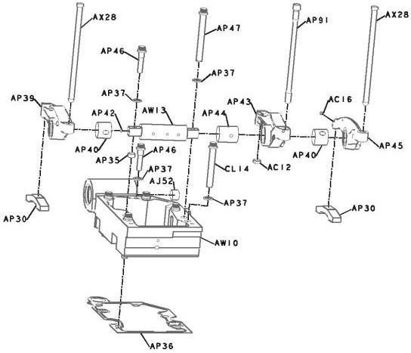

1. MANIFOLD, WATER – WM4725
   * A water manifold distributes coolant from the engine to various cooling channels.
   * Ensure even temperature regulation across all engine cylinders.
   * Connects to water pump, cylinder heads, and thermostat housing.
   * Made from cast aluminum, bronze, or composite materials.
   * Features internal passages that direct coolant to prevent hotspots.
   * Prevents engine overheating and maintains combustion chamber integrity.
   * Key part of the engine’s thermal management system.
2. MOTOR, STARTING – ST4071
   * A DC electric motor used to crank the engine during startup.
   * Draws power from the starting batteries to rotate the flywheel.
   * Engages the engine using a pinion gear and solenoid.
   * Disengages automatically after the engine starts to avoid damage.
   * Usually mounted on the flywheel housing and aligned with the ring gear.
   * Has high torque output for turning large diesel engines.
   * Needs strong electrical connections and clean contacts.
   * Essential for reliable engine ignition and power car operation.
3. MOUNTING, AIR CLEANER – AC4730
   * A structural bracket or clamp is used to secure the air cleaner to the engine.
   * Ensures the air filter stays in position even during vibrations.
   * Designed to isolate shock, vibration, and heat from the engine.
   * Helps maintain a tight air seal between filter and intake manifold.
   * Usually, it is made from metal with rubber inserts or bushings.
   * Must withstand engine bay conditions like heat, oil, and dust.

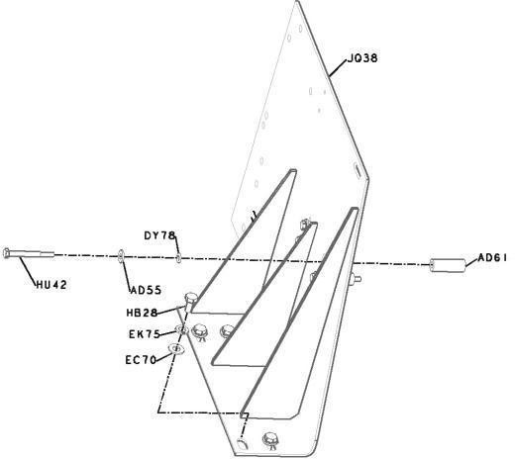

1. MOUNTING, GENERATOR – MG4047
   * A metal frame or bracket that holds the generator firmly in place.
   * Designed to support the weight and torque reaction of the generator.
   * Allows accurate belt or coupling alignment with the engine.
   * Reduces transfer of vibration or misalignment to the generator shaft.
   * Typically includes vibration isolators or rubber pads.
   * Mounting bolts must be properly torqued and inspected regularly.
   * Without this, generator performance and alignment will be compromised.
2. MOUNTING, STARTING MOTOR – SM4807
   * A specially designed support bracket for fixing the starting motor to the engine.
   * Maintains precise gear mesh alignment between motor pinion and flywheel ring.
   * Designed to withstand torque loads and vibration during engine cranking.
   * Usually, it includes steel or aluminum alloy flanges with bolt holes.
   * Integral for durable and reliable starting system performance.
   * Needs periodic inspection to avoid misalignment or damage to ring gear.
   * Damaged mounting can result in starter noise, gear chipping, or cranking failure.
3. MUFFLER – MU4018
   * A noise-suppressing component attached to the engine’s exhaust system.
   * Reduces engine noise and exhaust pressure using chambers and baffles.
   * Help maintain emission compliance and minimizes sound pollution.
   * Constructed from stainless steel or aluminized steel for corrosion resistance.
   * Installed downstream of the exhaust outlet or turbocharger.
   * Also reduces backpressure, improving engine performance if properly designed.
   * Essential for crew and passenger comfort due to reduced noise.

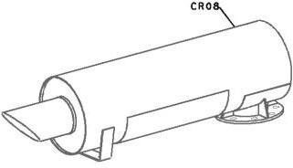

1. OIL, MANIFOLD – PP44575_OIL_MANIFOLD
   * A distribution block or pipe system for delivering lubricating oil to multiple engine parts.
   * Ensures uniform oil supply to components like bearings, camshafts, and rockers.
   * Helps maintain hydraulic pressure in the lubrication circuit.
   * Made from machined steel or cast alloy, with multiple internal channels.
   * Should be free of blockages, cracks, or leaks.
2. PAN, OIL – OP4084
   * The oil pan (or sump) is the reservoir where engine oil is stored.
   * Located at the bottom of the engine block, bolted and sealed tightly.
   * Collects returning oil from various engine parts.
   * Houses the oil drain plug and sometimes oil level sensor.
   * Must be made from cast aluminum or pressed steel to withstand heat and pressure.
   * Essential for holding and supplying lubricants for engine longevity.
3. PANEL, ENGINE – EG4061
   * A protective enclosure or cover panel for the engine compartment.
   * Shields the engine from dust, moisture, and mechanical impact.
   * Designed to be removable for routine engine maintenance.
   * Made from sheet metal or reinforced plastic composites.
   * Helps maintain cleanliness and thermal protection inside the engine bay.
   * Helps reduce engine noise and vibration by escaping to the coach.
   * Important for safety, durability, and operational integrity of the power car.
4. PISTON, ENGINE – PP44575_PISTON_ENGINE
   * The piston is a key moving part inside each engine cylinder.
   * It moves up and down (reciprocates), converting fuel combustion into mechanical force.
   * Connects to the crankshaft via the connecting rod.
   * Made from forged aluminum or cast alloy for strength and heat resistance.
   * It has piston rings that seal combustion gases and control oil film.
   * Transfers the combustion pressure to crankshaft rotation.
   * Also aids in heat dissipation from the combustion chamber to the cylinder walls.
   * Any damage leads to engine knock, power loss, or oil consumption.

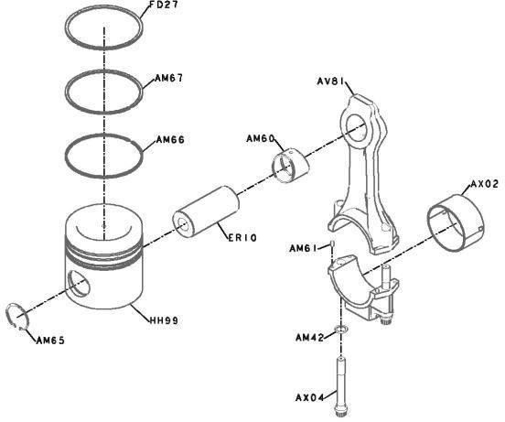

1. PLUMBING, FUEL FILTER – FF4737
   * Refers to the pipes, connectors, and hoses that link the fuel filter with other fuel system components.
   * Ensure smooth and leak-free flow of diesel fuel to and from the fuel filter.
   * Made using corrosion-resistant metal tubing or reinforced fuel-rated rubber hoses.
   * May include banjo bolts, hose clamps, and sealing washers.
   * Proper routing is critical to prevent fuel starvation or air locks.
   * Faulty or cracked lines can cause fuel leakage, fire risk, or engine stalling.
2. PLUMBING, OIL PAN – OP4890
   * Refers to the drain and return lines connected to the oil pan at the engine base.
   * Allow engine oil to drain from various parts back into the sump.
   * Must be resistant to high temperature and engine vibration.
   * Pipes are typically made of steel tubing or high-temp rubber hoses.
   * Includes drain plugs, oil level sensors, and sometimes dipstick tubes.
   * Failure here can cause oil leaks, low pressure, and engine damage.
3. PLUMBING, TURBOCHARGER – TP4762
   * Contains oil and air lines connected to and from the turbocharger unit.
   * Includes compressed air delivery to intake manifold and oil feed/return lines.
   * Air plumbing is made from aluminum or reinforced rubber hoses.
   * Oil lines are made from high-pressure resistant metal pipes.
   * Ensures turbo lubrication and air boost pressure delivery.
   * Vital for efficient turbocharger operation and engine performance.
   * Problems here lead to power loss, black smoke, or turbo failure.
4. RADIATOR – RA4039
   * The radiator dissipates heat from the engine coolant to the atmosphere.
   * Located at the front of the power car, exposed to airflow.
   * Made of aluminum or copper fins and tubes for high thermal efficiency.
   * Coolant flows through tubes while air removes heat via the fins.
   * Connected to inlet and outlet hoses, thermostat, and overflow tank.
   * Includes a pressure cap, drain plug, and sometimes a fan.
   * Keeps the coolant temperature within safe operating range.
   * Mounted with vibration-resistant supports and shrouds.

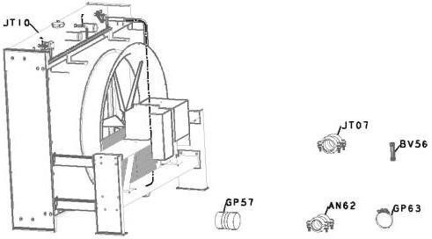

1. RESISTOR, CORROSION – WF4071
   * A sacrificial anode or corrosion control resistor used in cooling systems.
   * Protects metallic parts (e.g., radiator, cylinder head) from electrochemical corrosion.
   * Typically made of zinc, magnesium, or aluminum alloy.
   * Connected to coolant lines or blocks to neutralize galvanic action.
   * Absorbs corrosion currents and gradually degrade over time.
   * Plays a silent but vital role in engine maintenance.
   * Commonly used in diesel engines running in harsh environments.
2. SUPPORT, FRONT ENGINE – EM4135
   * This is a structural mount that supports the front end of the diesel engine.
   * It absorbs and distributes static and dynamic loads from the engine’s weight and operation.
   * Typically constructed from cast steel or fabricated steel brackets.
   * Mounted to the underframe of the power car and bolted to the engine block.
   * Includes vibration-damping rubber or elastomeric pads.
   * Reduces the transmission of engine vibrations and shocks to the car body.
   * Ensures alignment of the engine shaft with the alternator or other driven equipment.
   * Critical for engine safety, reliability, and long-term performance.
3. SUPPORT, REAR ENGINE – RE4712
   * Similar to the front support but mounted at the rear end of the engine.
   * Carries the rear portion of engine weight and maintains horizontal alignment.
   * Designed to withstand rotational torque and lateral movements.
   * Also made from high-strength steel and reinforced rubber bushings.
   * Provides a balanced mounting system in coordination with the front support.
   * Dampens vibrations that could damage connected systems like the generator.
   * Prevents excessive engine movement under load changes or rail shocks.
   * Key to reducing structural stress and prolonging engine-mount life.
4. TURBOCHARGER – PP4833
   * A high-speed forced induction device that compresses the intake air into the engine.
   * Increases air mass per cylinder, allowing more fuel to be burned efficiently.
   * It consists of a turbine (exhaust-driven) and compressor (air intake) mounted on a common shaft.
   * Powered by exhaust gases, making it energy-efficient with no mechanical drive losses.
   * Boosts engine power output without increasing cylinder size.
   * Requires lubrication and cooling, connected to oil and coolant circuits.
   * Made from heat-resistant alloys and precision-balanced components.
   * Damaged turbochargers lead to black smoke, low power, and poor engine performance.

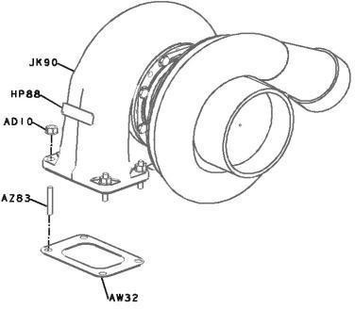

1. VALVE, CHECK – FS4077
   * A one-way valve that allows flow in only one direction and prevents reverse flow.
   * Used in various systems like fuel lines, lubrication, and coolant circuits.
   * Automatically closes when reverse pressure is applied.
   * Prevents backflow of diesel, oil, or coolant, protecting sensitive components.
   * Typically, spring-loaded with a poppet or ball-type internal mechanism.
   * Constructed from brass, stainless steel, or corrosion-resistant alloys.
   * Essential for maintaining system pressure integrity and preventing contamination.
   * Installed in critical lines where uncontrolled reverse flow could damage the engine.
   * Needs regular inspection to avoid blockages or jamming.
   * Plays a small but vital safety role in engine system stabili

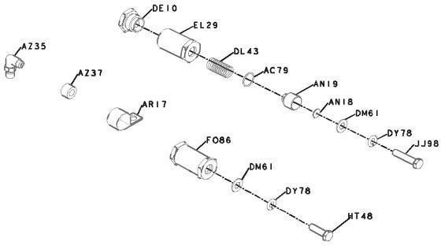

# DIESEL ALTERNATOR SETS FOR RAILWAY POWER CARS

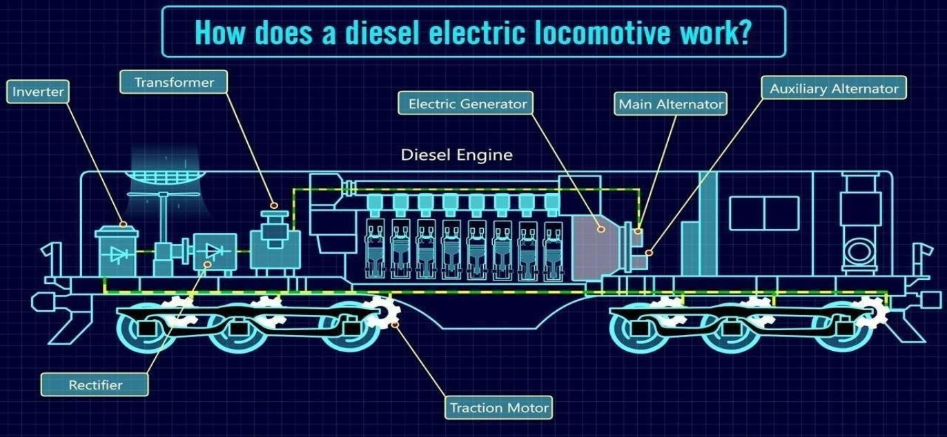

**Table of Contents**

* 1. Diesel Engine
* 2. Engine Cooling
* 3. Exhaust Arrangement
* 4. Alternator
* 5. Fuel System
* 6. Engine Room Ventilation
* 7. Engine Room Filters
* 8. Battery
* 9. Protections

#### DIESEL ENGINE

##### Working Principle in the Context of Railway Power Cars

Diesel engines in railway power cars use compression ignition to convert fuel into mechanical energy, which drives an alternator to generate electricity. This electricity powers both the traction motors and essential onboard systems such as lighting, air conditioning, and heating, ensuring passenger comfort and self-sufficient operation without relying on external power sources.

Diagram illustrating the working principle of a diesel-electric locomotive

### Engine Ratings Typically Used (Medium-Speed, High- Speed Engines)

Railway power cars use either medium-speed or high-speed diesel engines based on application needs. High-speed engines (≥1000 RPM) offer compact size and efficiency, ideal for high-speed trains, while medium-speed engines (450–800 RPM) provide durability and high torque for heavy freight or older passenger cars. The choice affects performance, noise, and maintenance.

##### Key Components (Turbochargers, Intercoolers, Engine Control Systems)

To optimize performance and efficiency, railway diesel engines incorporate several key components:

* **Turbochargers:** Use exhaust gases to compress more air into the cylinders, boosting power and efficiency, especially under load and at high altitudes.
* **Intercoolers:** Cool the compressed air from turbochargers, increasing air density for better combustion and reduced emissions.
* **Engine Control Systems (ECS):** Electronically manage fuel injection, air-fuel ratio, and other parameters for optimal performance, fuel efficiency, and integration with train monitoring systems.

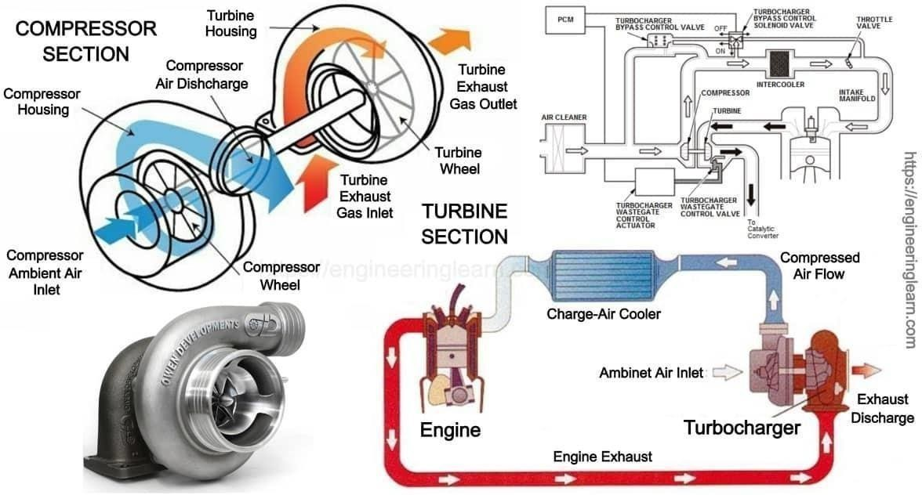

Diagram illustrating the components and airflow pathways of a turbocharger.

##### Load Profile Characteristics for Railway Hotel Load Applications

Hotel loads in railways refer to power for passenger amenities like lighting, air conditioning, and charging points Demand varies with factors like occupancy and weather. Diesel alternators supply stable 3-phase power, regulated by IGBT-base converters to ensure consistent voltage and frequency. The system handles sudden load changes to maintain uninterrupted service.

#### ENGINE COOLING

##### Preferred Cooling Methods (Radiator Cooling, Hydrostatic Fans, Rooftop Radiators) Used in Rolling Stock

* + **Radiator Cooling:** Large radiators cool engine jacket water, lube oil, and charge air, designed to handle the tough railway environment.
  + **Hydrostatic Fans:** Use hydraulic pumps and motors for variable-speed fan control, improving efficiency and reducing noise; typically mounted on rooftops or side panels.
  + **Rooftop Radiators:** Provide maximum cooling area and airflow, often using

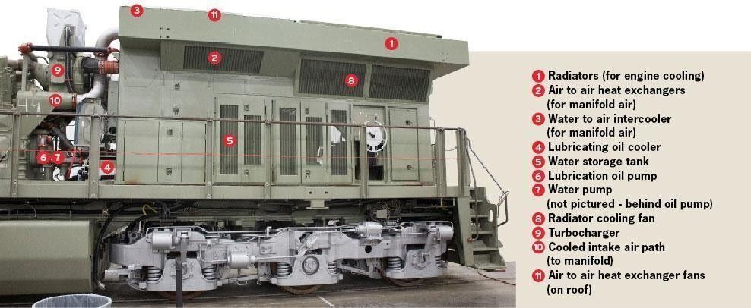

multiple fans for effective heat dissipation.

Example of a railway power car with radiator and fan installations.

##### Compact Cooling Design Constraints in Power Cars

* + **Lightweight and Modular Designs:** Use lightweight materials like aluminum alloys and modular units for easy installation and maintenance in tight spaces.
  + **High Heat Rejection Density:** Cooling systems must efficiently dissipate large amounts of heat in a compact area using optimized radiator fins and high- performance fans.
  + **Integration with Other Systems:** Cooling is integrated with the engine and thermal components to manage airflow, prevent hot spots, and maintain

##### Thermal Management for Continuous Operation Under Varying Ambient Conditions

* **Variable Speed Fans and Pumps:** Adjust cooling capacity dynamically to suit temperature and load, preventing overcooling or overheating.
* **Thermostatic Controls:** Monitor and regulate engine temperatures using thermostats and ECUs for optimal performance and longevity.
* **Bypass Systems:** Circulate coolant around the radiator in cold weather to help the engine warm up quickly.
* **Advanced Cooling Fluids:** Use specialized coolants with better heat transfer and freeze protection for varied climates.
* **Airflow Optimization:** Design ventilation to expel hot air and bring in cool air, avoiding heat buildup during stationary or slow operation.

#### EXHAUST ARRANGEMENT

##### Exhaust Routing in Railway Cars

The exhaust system in railway power cars safely directs hot, harmful gases away from the engine and passengers. Exhaust gases pass from the engine manifold through insulated pipes to silencers, then exit via the roof or sides. The routing avoids sensitive areas to prevent overheating and maintain safety, with insulation reducing heat radiation to protect components and ensure safe operation.

##### .Silencer Design for Noise Abatement per Railway Standards

* + **Design Principles:** Railway silencers use multi-chamber reactive and/or absorptive designs to target and reduce specific noise frequencies from diesel exhaust.
  + **Railway Standards:** Silencers must meet strict noise limits set by railway authorities (e.g., UIC standards) for various operating conditions.
  + **Compactness and Durability:** Silencers are designed to be compact for space constraints and durable enough to endure vibrations and temperature extremes in railway environments.

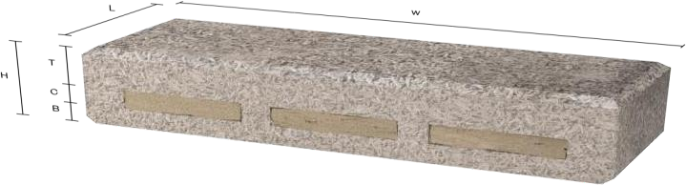Example of a Nexcem acoustic railway silencer module.

##### Emission Control Technologies for Compliance with Railway and Environmental Regulations (EPA Tier norms, UIC standards, CPCB norms, etc.)

* + **Emission Regulations:** Railway diesel engines must meet strict standards from bodies like EPA (Tier 4 in the USA), UIC (Europe), and CPCB (India).
  + **Diesel Particulate Filters (DPF):** Capture soot particles from exhaust gases.
  + **Selective Catalytic Reduction (SCR):** Uses urea-based fluid to convert NOx into nitrogen and water.
  + **Diesel Oxidation Catalysts (DOC):** Convert CO and hydrocarbons into less harmful substances.
  + 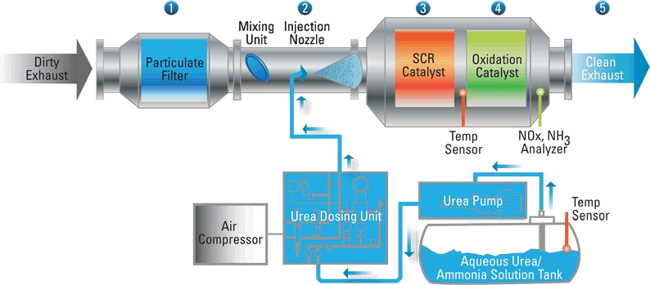**Engine Internal Technologies:** High-pressure fuel injection, optimized combustion, and Exhaust Gas Recirculation (EGR) help reduce emissions at the source.

#### ALTERNATOR

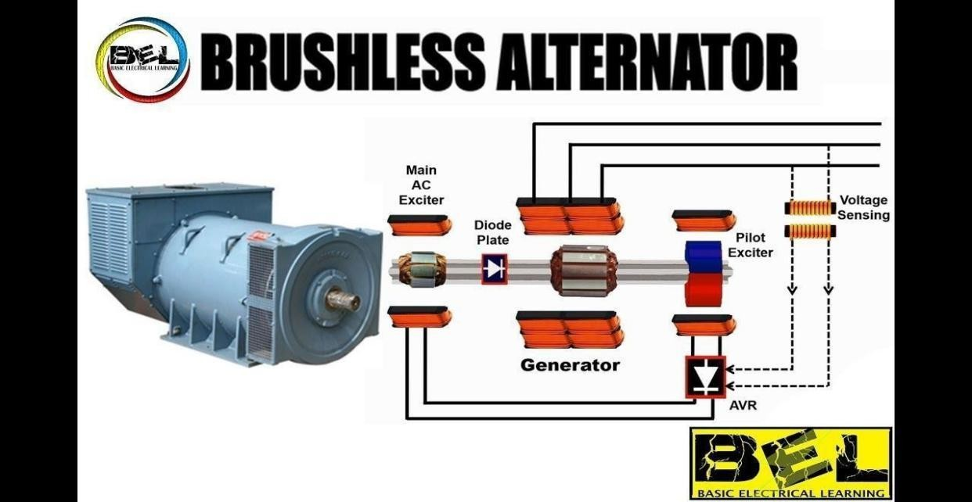

##### Alternator Types Used (Brushless Synchronous, PM Alternators, etc.)

Railway power cars mainly use brushless synchronous alternators for reliable, lowmaintenance AC power generation. Permanent magnet alternators, though less common, are used in auxiliary or hybrid systems for higher efficiency. Choice depends on efficiency, cost, and load needs.

Schematic diagram of a brushless alternator with its excitation system.

##### Load Handling: Traction Load vs. Hotel Load

Railway alternators are built to handle two main types of electrical loads:

* + **Traction Load:** Powers the traction motors in diesel-electric locomotives. This highpower, rapidly varying load (often in megawatts) changes with acceleration, cruising, and braking, requiring the alternator to deliver large, dynamic currents.
  + **Hotel Load:** Powers passenger amenities like HVAC, lighting, and entertainment. Though lower in magnitude, it requires highly stable voltage and frequency. Supplied via dedicated alternators or auxiliary windings, often through hotel load converters for precise regulation.

Modern systems increasingly integrate hotel load into the locomotive’s main alternator (HOG systems), reducing the need for separate power cars (EOG) and improving fuel efficiency.

##### Voltage Regulation and Stability Under Dynamic Railway Loads

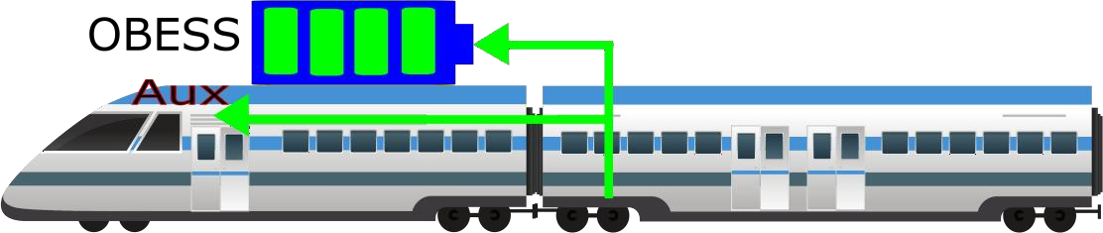

* + **Automatic Voltage Regulators (AVRs):** Control excitation in brushless alternators to maintain constant voltage despite speed and load changes.
  + **Dynamic Load Response:** Systems respond quickly to sudden load changes, keeping voltage within ±3% and frequency within ±1%.
  + **Harmonic Distortion:** Alternators and electronics are designed to handle harmonics from modern power devices, ensuring stable and reliable operation.

##### Synchronization Aspects When Multiple Alternators or HOG Connections Are Used

* + **Parallel Operation:** Multiple alternators must be synchronized in voltage, frequency, and phase before connecting to a common bus to avoid currents and ensure stability.
  + **Load Sharing:** Automatic systems distribute load proportionally among alternators, preventing overloads using droop or digital controls.
  + **HOG Systems:** The locomotive supplies power to the entire train’s hotel load, simplifying synchronization but requiring robust power conversion and distribution.

#### FUEL SYSTEM

Onboard Fuel Storage and Refueling Systems for Railway Power Cars

Railway power cars use durable diesel tanks built for safety and shock resistance. Refueling systems ensure fast, spill-free fuel transfer. Future trends include onboard hydrogen storage for fuel cell trains.

Illustration of a railway power car with underframe fuel tanks.

##### Fuel Transfer Systems, Fuel Tank Location (Typically Underframe)

**Fuel Pumps:** Electric or engine-driven pumps deliver fuel from the tank to the engine at proper pressure

**Return Lines:** Excess and heated fuel return to the tank to avoid overheating and maintain circulation.

**Fuel Tank Location:** Positioned under the power car between bogies for space use, stability, protection, and even weight distribution. Tanks are robust and require clearance near the rails.

##### Filtration Systems to Handle Fuel Quality Variations in Railway Environments

Multi-Stage Filtration:

***Primary Filters****:* Remove large particles and separate water to prevent corrosion.

*Secondary/Fine Filters:* Remove smaller contaminants to protect fuel injection parts.

**Contaminant Management:** Filters handle dust, dirt, and moisture common in railway settings; regular maintenance is vital for engine reliability.

**Specialized Filters:** High-performance filters are designed specifically for harsh railway conditions.

#### ENGINE ROOM VENTILATION

##### Design of Ventilation Systems in Compact, SoundInsulated Power Cars

* + **Air Intake and Exhaust:** Large louvers and exhaust fans draw in fresh air and expel heat, usually via roof or side walls.
  + **Sound Insulation:** Ventilation balances airflow with noise reduction using acoustic baffles and low-noise fans, crucial for noise standards.
  + **Pressurization:** Slight positive pressure may be used to keep out dust and debris.

3D rendering of an engine room ventilation system

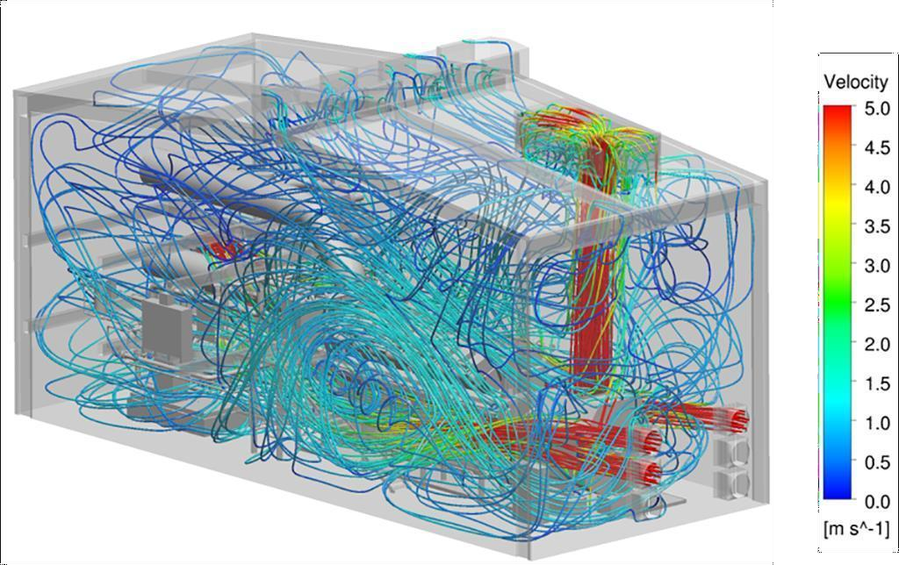

###### Airflow Management for Hot and Cold Zones

**Cold Air Intake**: Fresh air is drawn from lower areas or roof intakes to the engine and cooling systems.

**Hot Air Exhaust**: Hot air is expelled through roof vents or fans, using natural convection.

**Ducting and Baffles**: Ducts and baffles separate hot and cold air to prevent mixing and maintain optimal temperatures.

###### Safety Measures for Heat Buildup During Stationary/LowSpeed Operation

**Forced Ventilation**: Thermostatically controlled fans keep airflow even when stationary or slow.

**Auxiliary Cooling:** Additional electric fans or cooling loops run independently of main fans.

**Temperature Monitoring & Shutdowns**: Sensors trigger alarms and engine shutdowns if temperatures exceed safe limits.

**Idling Reduction**: Operators reduce engine idling to lower heat and emissions.

#### ENGINE ROOM FILTER

###### Engine Room Filters for Dusty, Vibration-Prone Environments

**Air Filters:** Multi-stage with pre-cleaners and durable pleated filters handle dust and vibration.

**Fuel Filters**: Multi-stage filtration removes particulates and water to protect fuel systems.

**Oil Filters**: High-efficiency filters remove wear particles; some use bypasses or centrifuge filtration for finer particles

.

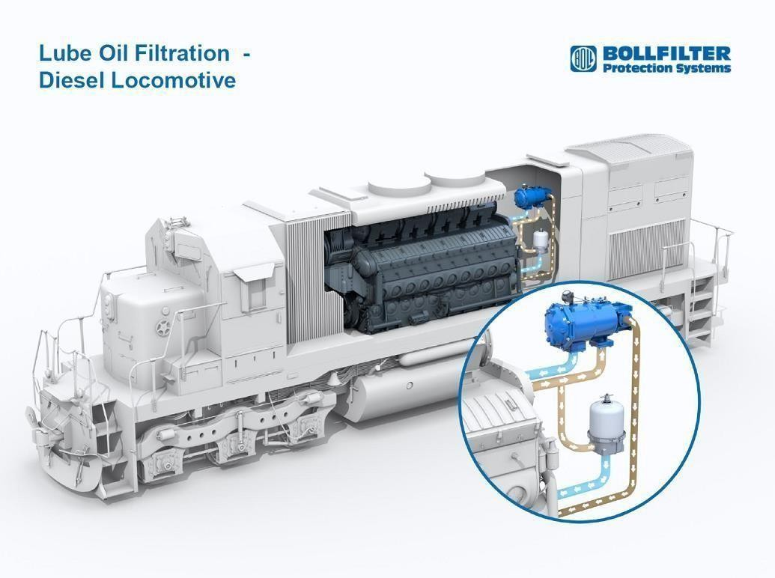

.

. Diagram of a railway diesel engine lubrication system, highlighting filtration

##### Maintenance Practices and Filter Replacement Intervals Suited for Railways

Maintenance Practices and Filter Replacement in Railways

* **Scheduled Maintenance:** Filters are replaced based on operational hours or mileage (e.g., every 1,000 engine hours or annually) to maintain filtration efficiency before significant wear.
* **Condition Monitoring:** Critical filters like lube oil filters may use oil analysis or pressure differential monitoring to optimize replacement timing.
* **Inspection:** Visual inspections of filter housings and elements are done regularly to detect damage, blockages, or leaks.
* **Manufacturer Recommendations:** Following engine and filter manufacturers’ guidelines is essential for warranty and engine health.

|  |  |
| --- | --- |
| Filter Type | Typical Replacement Interval |
| Engine Air Filter | 1,000 hours / Annually |
| Fuel Filters (Primary/Secondary) | 500-1,000 hours / Bi-annually |
| Engine Oil Filter | 500-1,000 hours / Annually (with oil change) |

### Pre-cleaners and Cyclone Separators Were

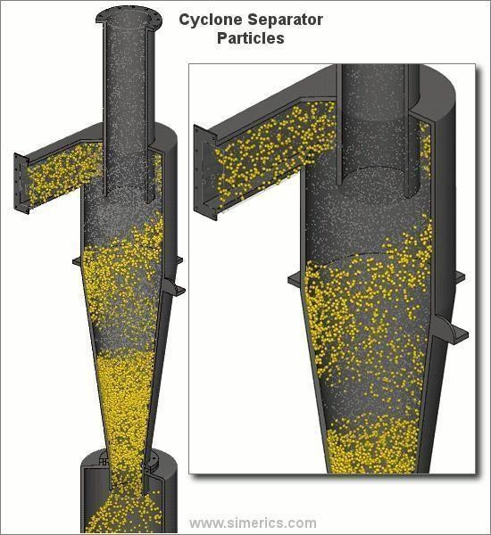

##### Applicable

Dusty railway conditions, **pre-cleaners** and **cyclone separators** are essential for protecting air filters and maintaining engine efficiency.

* + **Pre-cleaners:** Installed before the main air filter, they remove up to 90% of large dust particles and debris. This reduces the load on primary filters, extends their life, and lowers maintenance costs.
  + **Cyclone Separators:** A type of pre-cleaner using centrifugal force. Dusty air enters tangentially, forming a vortex—heavier particles are flung outward and collected, while cleaner air exits through the center. They’re passive, low- maintenance, and highly effective, especially in arid or industrial regions.

Animated diagram illustrating the working principle of a cyclone separator.

#### BATTERY

Battery Types Used for Starting and Control Circuits

Batteries in railway power cars are essential for engine starting and powering control/auxiliary systems when the main alternator is off.

* **Lead-Acid Batteries:** Commonly used due to their reliability, affordability, and high cranking power. Both flooded and VRLA types are used for starting, lighting, control systems, and emergency backup.
* **Lithium-Ion (Li-ion) Batteries:** Gaining popularity for their higher energy density, longer lifespan, fast charging, and better performance in extreme temperatures. Though costlier upfront, they offer better long-term value and are increasingly used in both hybrid/electric rail and diesel power car

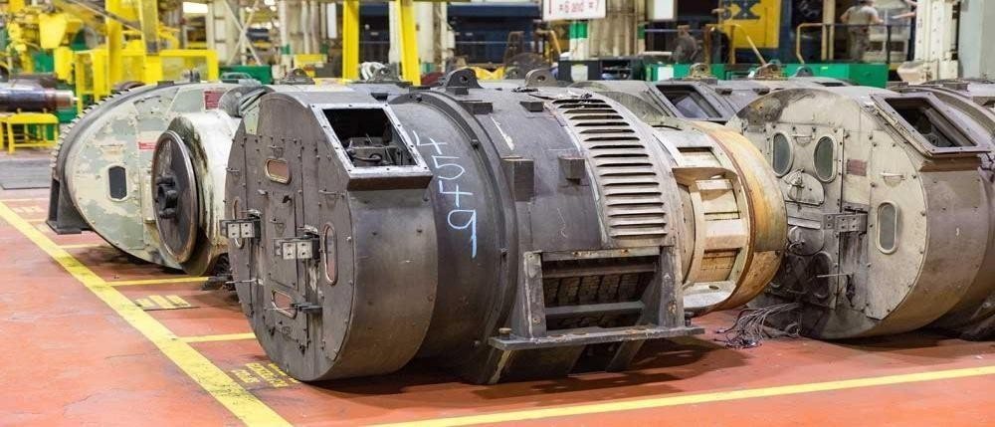

Diesel alternators, which work in conjunction with batteries for starting and control

##### Redundancy for Fail-Safe Operation in Rail Applications

Fail-safe design is critical in rail systems, especially for power components like batteries. Redundancy ensures essential operations continue during failures.

* **Multiple Battery Banks:** Independent banks provide backup if one fails.
* **Emergency Batteries:** Separate modules ensure key systems (engine start, comms, lighting) work even during failures.
* **Automatic Switchover:** Instantly shifts power to backup sources when the main fails.
* **CENELEC Compliance:** Designs follow railway safety standards (e.g., EN 50126/28/29) to meet required Safety Integrity Levels (SIL).

##### Battery Management Systems Designed for Railway Operational Profiles

Advanced BMS are essential for managing modern railway batteries, especially Li-ion.

* **Monitoring:** Tracks cell voltage, temperature, SoC/SoH in real time.
* **Balancing:** Ensures even charge/discharge among cells.
* **Protection:** Guards against overcharge, over-discharge, thermal events, and short circuits.
* **Thermal Management:** Integrated heating/cooling keeps batteries within optimal temperature range.
* **Communication:** Interfaces with TCMS for diagnostics and predictive maintenance.

#### PROTECTIONS

Diesel alternator sets in railway power cars are equipped with a comprehensive suite of protection systems, both electrical and mechanical, to ensure safe, reliable, and continuous operation. These protections safeguard the equipment, prevent costly damage, and enhance overall train safety.

##### Electrical Protections: Overload, Overvoltage, Earth Fault, Frequency Deviations, etc.

* + Overload Protection:

Prevents overheating and winding damage from excessive current using circuit breakers and overload relays.

* + Overvoltage Protection:

Protects electronics onboard from voltage spikes caused by load shedding or overspeed. Managed by AVRs and overvoltage relays.

* + Earth Fault Protection:

Detects insulation failures or unintended grounding

through RCDs or Earth Fault Relays, preventing shocks and equipment damage.

* + Frequency Deviations:

Maintains stable output (e.g., 50 Hz ±1–3%) via engine speed governors and alternator controls. Alarms or shutdowns activate if limits are breached.

* + Short Circuit Protection:

Instantly disconnects the alternator to prevent damage from high fault currents.

* + Reverse Power Protection:

Stops the alternator from drawing power in reverse, especially in parallel setups.

* + Under/Over Frequency & Voltage Protection:

Relays trip the system if output goes beyond permissible limits.

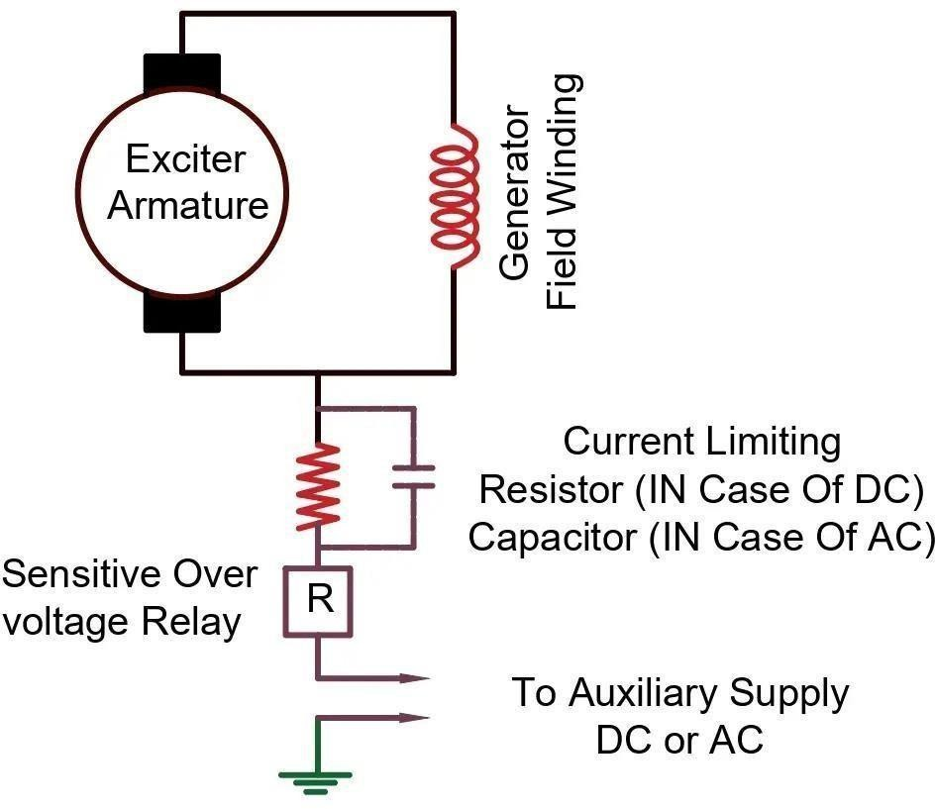

Diagram showing electrical protections for a diesel alternator, including earth fault protection.

##### Mechanical Protections: Oil Pressure, Coolant Temperature, Vibration Monitoring

Mechanical protections focus on the health and operational integrity of the diesel engine and associated rotating machinery.

* + **Low Oil Pressure:** Monitors the engine's lubricating oil pressure. A drop below critical levels indicates lubrication failure, which can lead to severe engine damage. Sensors trigger alarms and often automatically shut down the engine.
  + **High Coolant Temperature:** Monitors the engine's coolant temperature. Excessive temperatures indicate overheating, which can cause engine damage. Alarms and shutdowns are initiated if temperatures rise above safe operating limits.
  + **Vibration Monitoring:** Sensors (accelerometers) continuously monitor the vibration levels of the engine, alternator, and common base frame. Abnormal vibration patterns can indicate bearing wear, misalignment, unbalance, or other mechanical issues. Early detection through vibration analysis allows for predictive maintenance, preventing catastrophic failures.
  + **Overspeed Protection:** Prevents the engine from operating above its maximum safe RPM, which can lead to catastrophic mechanical failure. This is typically a redundant system, often mechanical and electronic.
  + **Low Coolant Level:** Detects insufficient coolant in the system, preventing overheating due to inadequate heat transfer.
  + **Crankcase Pressure:** Monitors pressure within the engine crankcase, which can indicate issues like blow-by from worn piston rings.

##### Remote Monitoring and Diagnostics Suitable for Railway Fleets

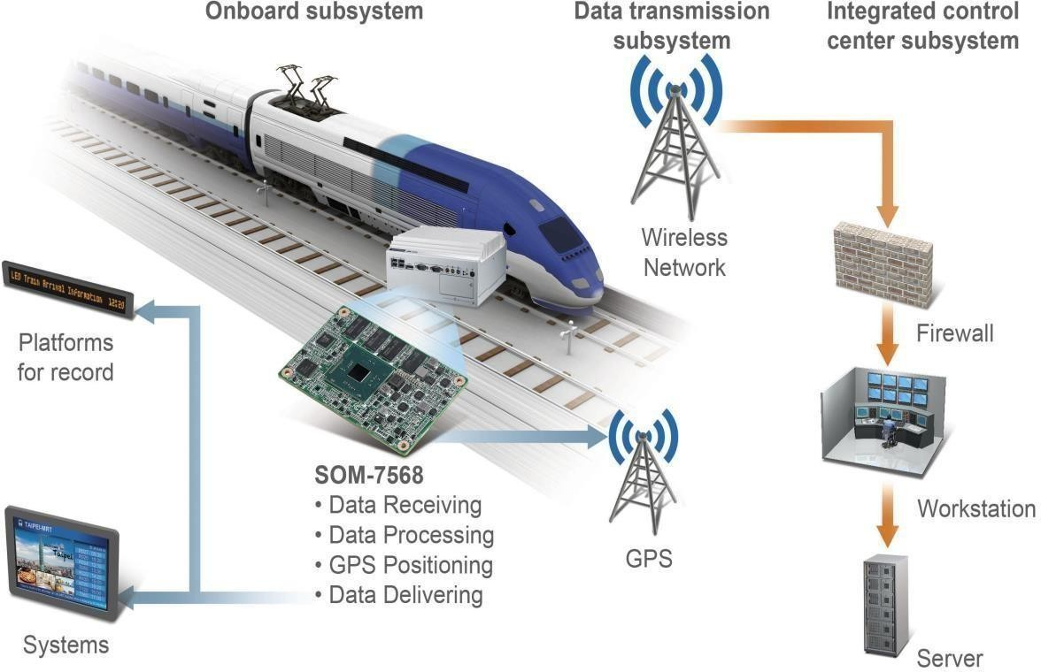

Modern railways use remote monitoring to improve the safety, efficiency, and reliability of diesel alternator systems.

* + **Real-time Data Acquisition:** Sensors transmit live data on RPM, temperature, pressure, voltage, current, fuel use, and emissions to centralized monitoring systems.
  + **Predictive Maintenance:** Analytics and machine learning identify patterns to forecast failures and schedule proactive maintenance, reducing downtime and costs.
  + **Fault Diagnostics:** Remote systems provide fault codes and diagnostics, allowing quick issue identification and troubleshooting.
  + **GPS Tracking & Geofencing:** Location-based monitoring adds operational context and enhances fleet visibility.
  + **Alerts & Notifications:** Automatic alerts notify staff when parameters exceed safe limits or anomalies are detected.

Infographic depicting components of a railway fleet remote monitoring and diagnostics system

### Interfacing with Train Control and Monitoring Systems (TCMS)

Diesel alternator protection and control systems are fully integrated with the Train Control and Monitoring System (TCMS), the central hub for coordinating all onboard systems.

###### Centralized Control:

The TCMS collects data from alternator sensors and controllers, enabling real-time monitoring of the power system.

###### Command & Control:

It can issue operational commands such as start/stop, load changes, and fault resets within safe limits.

###### Fault Reporting:

Faults (e.g., engine shutdown due to low oil pressure) are relayed to the TCMS, which logs the event, notifies the operator, and may initiate safety actions.

###### System Coordination:

The TCMS synchronizes power output with other train systems (propulsion, braking, HVAC), ensuring smooth and efficient train

operation.

# OPERATIONAL SAFETY AND PROTECTION IN POWER CARS

The operational safety and protection system in power cars involves a structured approach to plant selection and feeder distribution. A plant selection switch, located on the switchboard cabinet, is used to control which power plant supplies electrical energy. This switch has four distinct positions, each allowing a specific configuration of the power supply:

* **Position I (12 O’clock – OFF):** Both Plant A and Plant B are switched off.
* **Position II (3 O’clock – Plant A Only):** Only Plant A is in operation.
* **Position III (6 O’clock – Plant A & B):** Both Plant A and Plant B are operational; however, it is important to note that the alternators cannot be paralleled.
* **Position IV (9 O’clock – Plant B Only):** Only Plant B is in operation.

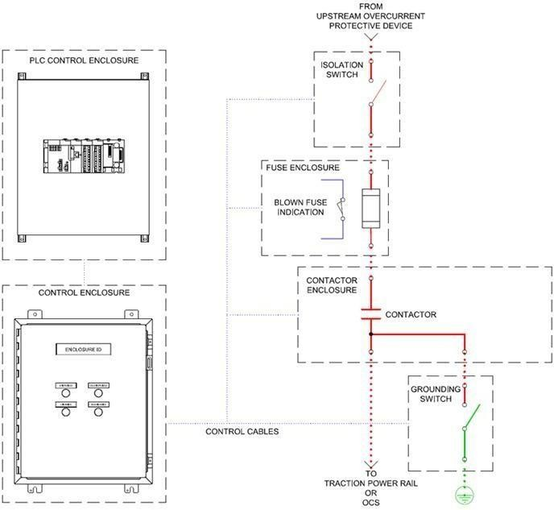

The inability to parallel the alternators is a critical safety feature, preventing damage to the system and ensuring safe operation under all load conditions.

Under normal conditions, **Feeder I** is powered by **Plant A** and **Feeder II** by **Plant B**. This division helps balance the load and maintain reliability. However, operational flexibility is provided through the use of a **bus coupler contactor push button** and individual **feeder contactors**. By using these controls, it is possible to configure the system such that either Plant A or Plant B can supply both Feeder I and Feeder II.

This capability is particularly useful in scenarios where one of the plants is under maintenance or if one plant is sufficient to meet the power demand. The design ensures that the power car system remains robust, adaptable, and safe under varying operational conditions.

In conclusion, the power distribution system in power cars is carefully engineered with safety and reliability in mind. The switchable modes, along with non-parallel operation and feeder flexibility, provide a comprehensive approach to managing power in dynamic rail environment.

## DC Control Isolation Switch and Control Panel Functions

The **DC Control Isolation Switch** is a rotary switch located on the switch cabinet. Its function is to cut off the DC supply to the control circuit when it is in the OFF position. This is an essential safety feature and must be activated (kept OFF) when the generator sets are not in operation. Doing so prevents unintentional engagement of control circuits and protects the equipment from unnecessary electrical stress.

The switch cabinet also includes a number of **push buttons and selector switches**, each designated for specific operational functions. These controls are vital for managing engine behavior, monitoring system faults, and handling feeder power distribution.

The table below outlines the major push buttons and switches provided on the switch cabinet and their corresponding functions:

|  |  |  |
| --- | --- | --- |
| **Sl.**  **No.** | **Name of Button/Switch** | **Function** |
| 1 | Engine ON | To start the engine |
| 2 | Rise | To increase the RPM of the engine |
| 3 | Lower | To decrease the RPM of the engine |
| 4 | Test Switch TS-1 | To test Engine Failure indication |
| 5 | Test Switch TS-2 | To test Alternator Failure indication |
| 6 | Test Lamp Switch | To test Feeder Failure indication |
| 7 | Alarm Isolation | To stop the alarm |
| 8 | Feeder ON | To switch ON the feeder |
| 9 | Engine STOP / RESET | To stop or reset the engine |
| 10 | Reset Push Button A or B | To reset alternator and feeder fault conditions |
| 11 | Feeder OFF | To switch OFF the feeder |
| 12 | Bus Coupler ON | To switch ON the bus coupler |

Each of these components plays a significant role in the reliable operation of the power car. Understanding their individual purposes ensures proper handling, minimizes downtime, and enhances operational safety.

# STARTING THE DG SET WITH CUMMINS ENGINE

The process of starting a Diesel Generator (DG) set equipped with a Cummins engine involves several precautionary steps and a specific starting sequence to ensure safe and efficient operation.

###### Precautions Before Starting

1. Confirm that **lubricating oil**, **fuel oil**, and **cooling water** are filled to the appropriate levels.

###### Ensure all switches are in good working condition. Starting Procedure

1. **Switch ON the DC Control Isolation Switch** – This will light the **DC ON** indication lamp, confirming control power availability.
2. **Switch ON the Starter Motor Isolation Switch** – This connects the **DC supply** from the starter battery to the starter motor circuit.
3. **Press Test Push Buttons 1, 2, and 3** – These check the status of fault indication lamps related to engine, alternator, and feeder conditions.
4. **Press the Engine Start Push Button** of the selected engine.

###### Functional Sequence During Starting

* + The **first NC (Normally Closed) contact** of the start button opens the **LOP (Lube Oil Pressure)** circuit. This interlock

prevents the engine from stopping due to low oil pressure during startup.

* + The **second NC contact** opens the starting circuit of the other engine, preventing both engines from starting simultaneously.
  + The **third NC contact** de-energizes the **BIC (Battery Interlock Contactor)** to disconnect the battery charger from the starter battery while starting.

Simultaneously:

* + **One NO (Normally Open) contact** energizes the **FSRD** (a time-delay relay for the starter solenoid) and **FSS** (Fuel Start Solenoid).
  + Another NO contact energizes the **SC (Solenoid Coil)** of the starting motor to crank the engine.

Once the engine reaches full speed:

* + Release the **Start Push Button**. The **FSRD’s instantaneous contacts** maintain power to **FSRD and FSS**.
  + The **starter motor circuit** remains open via the NC contact of the start button and a delay contact of FSRD to avoid accidental restarts.
  + Another NC delay contact of FSRD keeps the **LOP circuit closed** temporarily.

###### Post-Start Condition

Once the engine is running, **lube oil pressure** builds up and opens the **ICLOP (Internal Combustion Engine Low Oil Pressure switch)**. This ensures that the **LOP circuit remains energized** as long as the oil pressure is adequate.

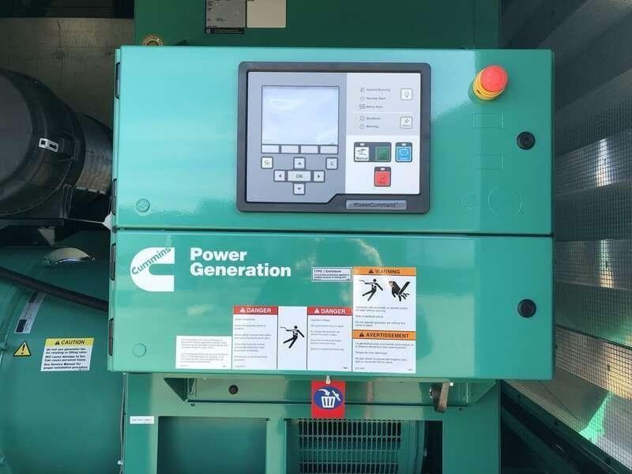

###### 

###### Adjustment of Engine Speed

To ensure that the diesel generator (DG set) produces electricity at the correct frequency, the engine speed must be properly adjusted.

The **frequency meter** on the control panel shows how fast the engine is running in terms of electrical frequency. For most systems, this frequency should be **50 Hz**.

To adjust the engine speed:

* + **Press the RISE button** if the frequency is lower than 50 Hz. This increases the engine speed.
  + **Press the LOWER button** if the frequency is higher than 50 Hz. This decreases the engine speed.

These buttons work by sending signals to the **throttle motor**, which controls how much fuel goes into the engine:

* + More fuel = higher speed
  + Less fuel = lower speed

By controlling the fuel flow in this way, we can accurately adjust the engine speed and make sure the generator works correctly and safely.

###### 

###### Protection System for Radiators and Roof Ventilators

To keep the diesel generator (DG set) from overheating, **radiators** and **roof ventilator fans** are used. These components need electrical power to run, and they also need protection to prevent damage from electrical faults.

Two **60 KVA transformers** are used to supply power to these motors. The transformers step down the voltage from **750V to 415V** using a **star/star connection**.

To protect the system from short circuits or overloads, **special fuses** called **HRC (High Rupturing Capacity) fuses** are installed on both sides of the transformer:

* + On the **input side**, a **63A, 1000V** fuse is used.
  + On the **output side**, a **100A, 660V** fuse is used.

The **radiator motor** is rated at **40 horsepower (HP)**. It gets power through a **star-delta starter**, which helps the motor start smoothly and reduces stress on the system. Inside the starter, a **Motor Protection Circuit Breaker (MPCB)** is used to protect the motor.

The **MPCB** is rated for **63A, 660V** and can be from a reliable brand like **Sprecher & Schuh or Siemens**. It protects the motor from:

* + **Overloading**
  + **Short-circuits**
  + **Phase loss (if one wire fails)**

This protection system ensures the radiator and ventilation fans work safely and efficiently, helping the DG set stay cool and perform well.

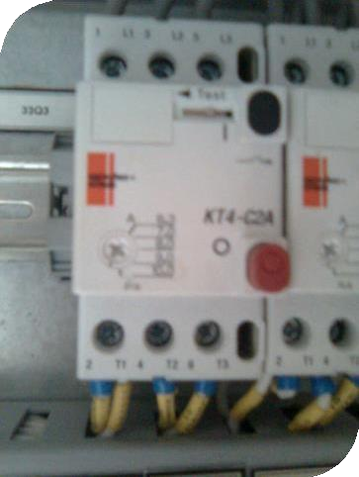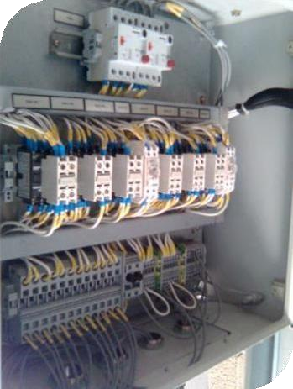

## 

## Earthing Concept

Earthing is used in electrical systems to **protect people and equipment** by safely sending any fault current into the ground. In the **LHB Power Car**, a proper earthing system is designed as per **IS:3043 standard**.

###### Generator Earthing (TN Network)

* + The **neutral point** of the generator is connected to the earth using a **neutral reactor**.
  + All metal parts that might become live in case of a fault are also connected to the earth.
  + This creates a system called a **TN network**, where the **generator**, **coupling plugs**, and **transformers** are all safely earthed.
  + Inside the control cabinet (S2), there is a **central earthing bar** (called PEN-bar) where all earth wires are connected.

###### Transformer Earthing (IT Network)

* + A **60 kVA transformer** is used in the power car. Its output (secondary) side is **not connected to the earth**, which creates an **IT network**.
  + In this system, if **one wire touches the body** or **gets damaged**, the current remains very small, and the system keeps working.
  + This makes the system **more reliable**, because it won’t stop working with just one fault.
  + If **two faults** happen at the same time, one of the faulty devices will **automatically shut off** before it becomes dangerous.

###### 110V DC System Protection

* + The **110V DC supply** is also **not earthed**. This provides

**double protection** for the devices using DC power.

* + There are special tools (keys and voltmeters) in the control panel to check the health of the system’s insulation.

###### Parts That Must Be Earthed

Some important parts of the coach are connected to the earth for safety:

###### Battery box

* + **Battery fuse boxes** (positive and negative)
  + **Transformer container**
  + **Fresh water tank**
  + **Brake electronics (PCB)**
  + **Diesel fuel tank**

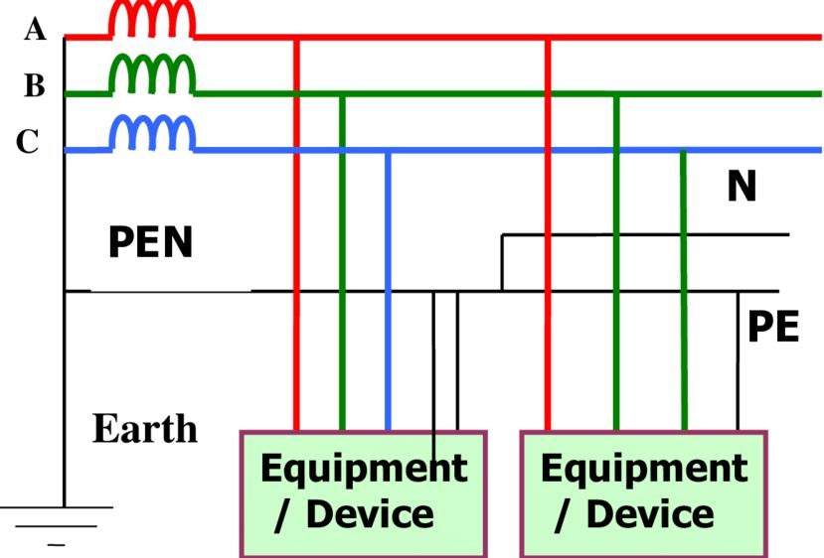

This system ensures both **safety** and **reliability** of the electrical setup in the generator car.

Schematic circuit connection for earthing system.

## 

## Smoke Detector:

Smoke detectors are installed in the power car to **detect any smoke or fire** that may happen due to overheating or electrical faults.

###### What does it include?

* + A **control unit** with:
    - Lights to show smoke level
    - A buzzer sound to alert nearby staff
    - A connection for loud alarms (called hooters)
  + **Two smoke detectors** are placed:

###### One above the power panel

* + - One **inside the engine room**
  + **Two hooters (loud alarms)** are placed in the same areas to give an immediate warning if smoke is detected.
  + The system runs on **110V DC power**, taken from the battery of the coach.

###### Why is it needed?

* + It helps with detecting:

###### Short circuits

* + - **Overheating of electrical wires**
    - Burning **plastic insulation** (like PVC), which gives off smoke

This system helps in **early detection** of fire risks and ensures safety of the power car and passengers.

## Relay Protection for Generator Car:

Relays are safety devices used in the **generator car** to protect it from damage. They work by **monitoring different parts of the system**, and when a fault or unusual condition is detected—like too much current, high temperature, or low oil pressure—the relays **automatically stop or control the system** to avoid accidents.

###### Main Areas of Protection

1. **Power Generation System:**
   * **Earth Leakage Relays**: Detect any current leaking to the ground, which could be dangerous.
   * **Under Voltage Relay**: Trips the system if voltage goes too low.
   * **Overload Relays**: Protects the feeder from carrying too much current for too long.
   * **Air Circuit Breaker**: Acts like a main safety switch that trips during high current flow.
   * **Over-Speed Relay**: Stops the engine if it runs too fast.
   * **Temperature Switches**: Monitors engine water temperature; trips if it gets too hot.
   * **Low Oil Pressure Switch**: Stops the engine if there is not enough lubrication oil.

###### AC System Protection:

* + **Overload Relays**: Protects motors of compressor, condenser, and blower from overheating due to high current.
  + **Low- and High-Pressure Cutouts**: Ensures the air conditioning system runs at safe pressure levels.

###### Why These Relays Are Important

* They help **avoid serious damage** to the generator and electrical systems.
* They ensure the **safety of passengers and staff** by preventing fire or mechanical failure.

###### They reduce maintenance costs and increase reliability

of the power car.

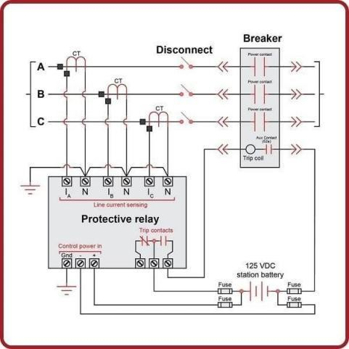

Schematic Diagram for Relay Protection for Generator Car

## Comparison of Conventional and Upgraded Power Cars

In older trains, the power cars used a Cummins engine model that wasn't strong enough to handle the full electrical load required. To fix this, the **upgraded power cars**—especially in **LHB and Garib Rath coaches**—were equipped with a more powerful engine. This helped improve overall performance and reliability.

Here's a simple comparison:

###### Engine Model:

The older power car used the **KTA-1150** engine, while the upgraded one uses a **KTA19-G5I** engine, which is more advanced and efficient.

###### Power Output:

The engine in the conventional car produced **450 BHP**, but the new one produces **490 BHP**, meaning it can generate more power.

###### Electrical Capacity:

The old system could supply **336 kW**, but the new system

provides **420 kVA**, which is enough to run more equipment on the train.

###### Cooling System:

The radiator motor in the old system was **20 HP**, while the upgraded system has a **40 HP radiator motor** to handle the extra heat from the more powerful engine.

###### Conclusion:

The upgraded power cars are better suited for modern trains because they are **more powerful**, **more efficient**, and can handle **higher electrical loads** safely.

### 